 

# REAL-TIME RISK ALERT SYSTEM FOR OLIGURIC DIALYSIS PATIENTS USING ARDUINO

### A PROJECT REPORT

***Submitted by***

**KEERTHANA D (927621BEC082)**

**KIRUBASHINI P (927621BEC089)**

**KIRUTHIGA M (927621BEC090)**

**LAKSHITHA S M (927621BEC100)**

***in partial fulfillment for the award of the degree of***

# BACHELOR OF ENGINEERING

**in**

**ELECTRONICS AND COMMUNICATION ENGINEERING**

# M.KUMARASAMY COLLEGE OF ENGINEERING, KARUR ANNA UNIVERSITY: CHENNAI 600 025

### APRIL 2025

**M.KUMARASAMY COLLEGE OF ENGINEERING, KARUR**

# BONAFIDE CERTIFICATE

Certified that this project report **“REAL-TIME RISK ALERT SYSTEM FOR OLIGURIC DIALYSIS PATIENTS USING ARDUINO”**

is the Bonafide work of **“KEERTHANA D (927621BEC082), KIRUBASHINI P (927621BEC089), KIRUTHIGA M (927621BEC090),**

**LAKSHITHA S M (927621BEC100)”** who carried out the project work under my supervision in the academic year 2024-2025.

|  |  |
| --- | --- |
| **SIGNATURE** | **SIGNATURE** |
| **Dr.A.KAVITHA, M.E., Ph.D.,** | **Dr.A.SRIDEVI, M.E., Ph.D.,** |
| **HEAD OF THE DEPARTMENT**  Professor,  Department of Electronics and Communication Engineering, M.Kumarasamy College of Engineering, Thalavapalayam, Karur-639113 | **SUPERVISOR**  Associate Professor**,** Department of Electronics and Communication Engineering,  M.Kumarasamy College of Engineering, Thalavapalayam, Karur-639113 |

This project report has been submitted for the **18ECP107L - Project Work** Viva Voce Examination held at M.Kumarasamy College of Engineering, Karur on .

**INTERNAL EXAMINER EXTERNAL EXAMINER**

# INSTITUTION VISION AND MISSION

**Vision**

To emerge as a leader among the top institutions in the field of technical education.

**Mission**

**M1:** Produce smart technocrats with empirical knowledge who can surmount the global challenges.

**M2:** Create a diverse, fully -engaged, learner -centric campus environment to provide quality education to the students.

**M3:** Maintain mutually beneficial partnerships with our alumni, industry and professional associations

# DEPARTMENT VISION, MISSION, PEO, PO AND PSO

**Vision**

To empower the Electronics and Communication Engineering students with emerging technologies, professionalism, innovative research and social responsibility.

**Mission**

**M1:** Attain the academic excellence through innovative teaching learning process, research areas & laboratories and Consultancy projects.

**M2:** Inculcate the students in problem solving and lifelong learning ability.

**M3:** Provide entrepreneurial skills and leadership qualities.

**M4:** Render the technical knowledge and skills of faculty members.

**Program Educational Objectives**

**PEO1: Core Competence:** Graduates will have a successful career in academia or industry associated with Electronics and Communication Engineering

**PEO2: Professionalism:** Graduates will provide feasible solutions for the challenging problems through comprehensive research and innovation in the allied areas of Electronics and Communication Engineering.

**PEO3: Lifelong Learning:** Graduates will contribute to the social needs through lifelong learning, practicing professional ethics and leadership quality

**Program Outcomes**

**PO 1: Engineering knowledge:** Apply the knowledge of mathematics, science, engineering fundamentals, and an engineering specialization to the solution of complex engineering problems.

**PO 2: Problem analysis:** Identify, formulate, review research literature, and analyze complex engineering problems reaching substantiated conclusions using first principles of mathematics, natural sciences, and engineering sciences.

**PO 3: Design/development of solutions:** Design solutions for complex engineering problems and design system components or processes that meet the specified needs with appropriate consideration for the public health and safety, and the cultural, societal, and environmental considerations.

**PO 4: Conduct investigations of complex problems:** Use research-based knowledge and research methods including design of experiments, analysis

and interpretation of data, and synthesis of the information to provide valid conclusions.

**PO 5: Modern tool usage:** Create, select, and apply appropriate techniques, resources, and modern engineering and IT tools including prediction and modeling to complex engineering activities with an understanding of the limitations.

**PO 6: The engineer and society:** Apply reasoning informed by the contextual knowledge to assess societal, health, safety, legal and cultural issues and the consequent responsibilities relevant to the professional engineering practice.

**PO 7: Environment and sustainability:** Understand the impact of the professional engineering solutions in societal and environmental contexts, and demonstrate the knowledge of, and need for sustainable development.

**PO 8: Ethics:** Apply ethical principles and commit to professional ethics and responsibilities and norms of the engineering practice.

**PO 9: Individual and team work:** Function effectively as an individual, and as a member or leader in diverse teams, and in multidisciplinary settings.

**PO 10: Communication:** Communicate effectively on complex engineering activities with the engineering community and with society at large, such as, being able to comprehend and write effective reports and design documentation, make effective presentations, and give and receive clear instructions.

**PO 11: Project management and finance:** Demonstrate knowledge and understanding of the engineering and management principles and apply

these to one’s own work, as a member and leader in a team, to manage projects and in multidisciplinary environments.

**PO 12: Life-long learning:** Recognize the need for, and have the preparation and ability to engage in independent and life-long learning in the broadest context of technological change.

**Program Specific Outcomes**

**PSO1:** Applying knowledge in various areas, like Electronics, Communications, Signal processing, VLSI, Embedded systems etc., in the design and implementation of Engineering application.

**PSO2:** Able to solve complex problems in Electronics and Communication Engineering with analytical and managerial skills either independently or in team using latest hardware and software tools to fulfil the industrial expectations.

|  |  |
| --- | --- |
| **Abstract** | **Matching with POs, PSOs** |
| BMP280, NodeMCU,  GSM Modules, Heartbeat Sensor, Flow Sensor. | PO1, PO2, PO3, PO4, PO5, PO6, PO8, PO9, PO10, PO11, PO12, PSO1, PSO2 |

|  |  |  |
| --- | --- | --- |
| **S.No.** | **Project Domain** | **Mapping with POs/PSOs** |
| 1 | Embedded Systems | PO1, PO2, PO3, PO4, PO6, PO7, PO9, PO12, PSO1, PSO2 |
| 2 | IoT | PO1, PO2, PO3, PO4, PO5, PO6, PO8, PO9, PO10, PO11, PO12, PSO1, PSO2 |

# ACKNOWLEDGEMENT

We gratefully remember our beloved **Founder Chairman, (Late) Thiru. M. Kumarasamy**, whose vision and legacy laid the foundation for our education and inspired us to successfully complete this project.

We extend our sincere thanks to **Dr. K. Ramakrishnan, Chairman**, and **Mr.**

**K. R. Charun Kumar, Joint Secretary**, for providing excellent infrastructure and continuous support throughout our academic journey.

We are privileged to extend our heartfelt thanks to our respected Principal, **Dr.**

**B. S. Murugan, B.Tech., M.Tech., Ph.D.,** for providing us with a conducive environment and constant encouragement to pursue this project work.

We sincerely thank **Dr. A. Kavitha, B.E., M.E., Ph.D.,** Professor and **Head, Department of Electronics and Communication Engineering**, for her continuous support, valuable guidance, and motivation throughout the course of this project.

Our special thanks and deep sense of appreciation go to our **Project Supervisor, Dr. A. Sridevi, B.E., M.E., Ph.D.,** Associate Professor, **Department of Electronics and Communication Engineering,** for his exceptional guidance, continuous supervision, constructive suggestions, and unwavering support, all of which have been instrumental in the successful execution of this project.

We would also like to acknowledge **Dr. S. Vimalnath, B.E., M.E., Ph.D., Associate Professor, our Class Advisor,** and **Dr. S. Vimalnath**, **B.E., M.E., Ph.D.,** the **Project Coordinator**, for their constant encouragement and coordination that contributed to the smooth progress and completion of our project work.

We gratefully thank all the **faculty members of the Department of Electronics and Communication Engineering** for their timely assistance, valuable insights, and constant support during various phases of the project.

Finally, we extend our profound gratitude to our **parents and friends** for their encouragement, moral support, and motivation, without which the successful completion of this project would not have been possible.

# ABSTRACT

Oliguria, defined by a significant reduction in urine output, is a critical condition that can lead to severe complications in dialysis patients, including fluid overload, electrolyte imbalances, and cardiovascular instability. Effective and timely detection of oliguria is crucial to mitigate these risks and ensure optimal patient care. This project presents a comprehensive real-time risk alert system to monitor dialysis patients at risk of developing oliguria. Utilizing an Arduino platform, the system integrates multiple sensors to continuously track essential vital signs such as heart rate, blood pressure, and dialysis fluid flow. Additionally, the system supports real-time data monitoring through a web dashboard, which provides healthcare professionals with ongoing updates on patient status and allows for informed decision- making. To ensure prompt awareness, an LCD display is incorporated in the facility for visual feedback, while a buzzer offers immediate audio alerts for critical deviations in patient condition. The system was tested on dialysis patients and showed accurate vitals monitoring, such as temperature ranging from 35.92°C to 38.93°C and heart rate from 60 to 100 BPM. For instance, one patient showed an abnormal reading of 38.93°C with a heart rate of 109.76 BPM and 48.98 ml/s urinary flow, which triggered an instant GSM alert. In contrast, a normal reading example showed 38.25°C, 65.66 BPM, and 148.96 ml/s urinary flow. The system's timely alerts and user- friendly dashboard ensured quick response and improved patient care.

**Keywords**: Oliguria, Internet of Things (IOT), Health Monitoring, NodeMCU, Buzzer**.**

**TABLE OF CONTENTS**

|  |  |  |
| --- | --- | --- |
| **CHAPTER**  **No.** | **CONTENTS** | **PAGE No.** |
|  | **INSTITUTION VISION AND MISSION** | **iii** |
|  | **DEPARTMENT VISION AND MISSION** | **iii** |
|  | **DEPARTMENT PEOS, POS AND PSOS** | **iv** |
|  | **ABSTRACT** | **ix** |
|  | **LIST OF TABLES** | **xiv** |
|  | **LIST OF FIGURES** | **xv** |
|  | **LIST OF ABBREVIATIONS** | **xvi** |
| **1** | **INTRODUCTION** | **1** |
| **2** | **LITERATURE SURVEY** | **5** |
|  | 2.1 Microcontroller-Based Health  Monitoring Systems | 5 |
|  | 2.2 GSM and IoT-Based Medical Alert Systems | 6 |
|  | 2.3 Biomedical Sensor Integration for | 6 |
|  | Dialysis Monitoring |  |
|  | 2.4 Urine Output Monitoring Systems in | 7 |
|  | Clinical Practice |  |
|  | 2.5 Arduino Integration with Medical  Sensors | 7 |
|  | 2.5 Alert Mechanisms in Critical Patient | 8 |
|  | Monitoring |  |

|  |  |  |
| --- | --- | --- |
|  | 2.7 Low-Power and Portable Health Devices | 8 |
|  | 2.8 Importance of Real-Time Data  Acquisition in Patient Monitoring | 9 |
|  | 2.9 Application of Flow and Pressure  Sensors in Medical Devices | 9 |
|  | 2.10 Challenges in Home-Based Patient  Monitoring Systems | 10 |
|  | 2.11 Use of Cloud Platforms in Health  Data Storage and Monitoring | 10 |
| **3** | **EXISTING SYSTEM** | **11** |
|  | 3.1. Clinical Importance of Monitoring  Oliguria in Dialysis Patients | 11 |
|  | 3.2. Limitations of Traditional  Monitoring Methods | 11 |
|  | 3.3. Absence of Real-Time Alerts | 12 |
|  | 3.4. Lack of Home-Based Monitoring | 13 |
|  | 3.5 Incompatibility with IoT and  Remote Healthcare Models | 14 |
|  | 3.6. Arduino in Biomedical  Applications | 15 |
| **4** | **PROPOSED SYSTEM** | **16** |
|  | 4.1 GSM Modules Enable Connectivity | 17 |
|  | 4.2 Power Supply is Essential for  Functionality | 17 |

|  |  |
| --- | --- |
| 4.3 Node MCU Simplifies IoT Development  4.4 Flow Sensors Monitor Liquid  Dynamics | 17  18 |
| 4.5 Heartbeat Sensors Enhance Health  Monitoring | 18 |
| 4.6 Temperature and Pressure Readings | 18 |
| 4.7 Buzzers Facilitate User Alerts and  Notifications | 19 |
| 4.8 Program Implementation | 19 |
| 4.9 Hardware requirements | 21 |
| 4.9.1 Arduino UNO | 21 |
| 4.10 Schematic & reference design | 24 |
| 4.10.1 Power | 24 |
| 4.10.2 Memory | 25 |
| 4.10.3 Input and Output | 26 |
| 4.10.4 Power supply | 27 |
| 4.10.5 Transformer | 27 |
| 4.10.6 Rectifier | 27 |
| 4.10.7 Filters | 27 |
| 4.10.8 Voltage regulator | 28 |
| 4.10.9 Capacitor | 28 |

|  |  |  |
| --- | --- | --- |
|  | 4.10.10 Voltage Rating of a  Capacitor | 31 |
|  | 4.10.11 NodeMCU | 32 |
|  | 4.10.12 Liquid Crystal Display | 34 |
|  | 4.10.13 BMP280 Sensor | 35 |
| **5** | **EXPERIMENTAL PROCEDURE** | **37** |
|  | 5.1 Continuous Monitoring | 37 |
|  | 5.1.1. Heartbeat Sensor | 37 |
|  | 5.1.2. BMP280 Pressure Sensor | 38 |
|  | 5.1.3. Flow Sensor | 38 |
|  | 5.1.4. Temperature Sensor | 39 |
|  | 5.2. Data Processing | 39 |
|  | 5.3. Alert Mechanism | 40 |
|  | 5.4. Visualization | 41 |
| **6** | **RESULT AND DISCUSSION** | **42** |
| **7** | **CONCLUSION AND FUTURE**  **WORK** | **48** |
|  | **APPENDICES** | **50** |
|  | **REFERENCES** | **58** |

**LIST OF TABLES**

|  |  |  |
| --- | --- | --- |
| **TABLE**  **No.** | **TITLE** | **PAGE No.** |
| 4.1 | Comparison between existing model and proposed model | 20 |
| 4.2 | Arduino UNO Specifications | 23 |
| 6.1 | Normal Results | 43 |
| 6.2 | Abnormal Results | 45 |

**LIST OF FIGURES**

|  |  |  |
| --- | --- | --- |
| **FIGURE**  **No.** | **TITLE** | **PAGE No.** |
| 3.1 | Traditional monitoring methods | 12 |
| 3.2 | Remote healthcare model | 15 |
| 4.1 | Proposed System Design | 16 |
| 4.2 | Multi-sensor board Arduino | 19 |
| 4.3 | Arduino UNO | 22 |
| 4.4 | Five Volts Power Supply | 28 |
| 4.5 | Capacitor | 29 |
| 4.6 | NodeMCU | 33 |
| 4.7 | BMP280 Sensor | 36 |
| 5.1 | SMS Alert | 40 |
| 5.2 | LCD Output | 41 |
| 6.1 | Chart represents Normal output | 44 |
| 6.2 | Chart represents Abnormal output | 46 |

**LIST OF ABBREVIATIONS**

|  |  |  |
| --- | --- | --- |
| **ACRONYM** |  | **ABBREVIATION** |
| IOT | - | Internet Of Things |
| CKD | - | Chronic kidney disease |
| AKI | - | Acute Kidney Injury |
| GSM | - | Global System for Mobile Communication |
| BMP280 | - | Barometric Pressure |
| LCD | - | Liquid Crystal Display |
| SMS KDIGO | -  - | Short Message Service  Kidney Disease: Improving Global Outcomes |

**CHAPTER 1 INTRODUCTION**

Chronic kidney disease (CKD) is a growing global health concern,

with many patients eventually requiring dialysis as a life-sustaining treatment. Among the complications faced by dialysis patients, oliguria— a condition marked by reduced urine output—typically less than 400–500 mL per day in adults, as it may indicate underlying complications such as fluid overload, cardiovascular instability, or the progression of renal failure. Continuous monitoring and timely alerting of such conditions are essential to improve patient outcomes and prevent severe complications. Traditional monitoring methods often rely on manual measurements and intermittent observations, which can lead to delays in detecting early warning signs.

To address this gap, this project proposes the development of a Real- Time Risk Alert System for Oliguric Dialysis Patients using Arduino-based technology. The system is designed to continuously monitor urine output and trigger real-time alerts when output falls below clinically significant thresholds. By integrating sensors, microcontrollers, and alert mechanisms, this system provides an affordable, portable, and efficient solution that can be deployed in both clinical and home-care settings. The use of Arduino allows for cost-effective implementation while maintaining flexibility and ease of customization. This report outlines the design, development, and implementation of the system, highlighting its potential to enhance patient safety through early risk detection and intervention.

The Internet of Things (IoT) has changed how chronic diseases are monitored and managed in healthcare. IoT health monitoring systems track vital signs in real-time using wearable devices with sensors. This continuous data collection helps detect health issues early, which is crucial for patients needing long term care. The systems analyze data to identify any abnormal readings and send alerts to patients and healthcare providers for quick intervention. Personalized alert thresholds can be set based on individual health needs, enhancing the monitoring's effectiveness and supporting tailored treatments. This approach encourages patient engagement and adherence to treatment plans, leading to better health outcomes. focused on developing a reliable method to detect low urine output (oliguria) in dialysis patients.

Researchers created an embedded system continuous monitoring of urinary bladder volume, providing real- time data to alert healthcare providers of significant changes. This system outperformed traditional nursing assessments by improving the accuracy of oliguria detection. Early detection allowed for timely interventions, reducing the risk of complications from acute kidney injury. research emphasizes the need for continuous monitoring in critically ill patients on dialysis, as urine output is essential for assessing renal function. Integrating advanced monitoring systems into care protocols can help healthcare providers respond more effectively, enhancing patient outcomes. This work underscores the importance of technological advancements in healthcare, particularly in critical care settings. review highlights various sensor technologies used for real-time monitoring of bladder conditions. These include pressure sensors, volume sensors, and wireless telemetry systems that enable continuous data collection without invasive methods.

This allows healthcare providers to customize treatments for issues like overactive bladder and urinary retention. Methodological considerations for designing these sensors focus on biocompatibility, accuracy, and reliability, as well as challenges of long-term use. The improved sensor designs for better functionality and patient comfort and recommend more clinical trials to validate these technologies across different patient groups. A new wearable device has been developed to continuously monitor bladder volume, overcoming the shortcomings of invasive methods that need skilled personnel and may not deliver timely information. This device employs ultrasonic technology for accurate measurement and features flexible transducers and transmission in daily environments.

The aim is to enhance the care of patients with lower urinary tract issues by providing essential information without invasive procedures. This system can significantly aid those with urinary incontinence or neurogenic bladder dysfunction by offering timely alerts for bladder management. The study emphasizes the promise of further developments in non-invasive bladder monitoring, which could improve patient care in urology. research addressed the varying rates of acute kidney injury (AKI) in intensive care units (ICUs), which often suffer from biases like incomplete definitions. The AKI-EPI study was a multinational analysis involving 97 centers and focused on patients in their first week of ICU admission, using the KDIGO criteria for assessing AKI. Among 1802 ICU patients, 57.3% were diagnosed with AKI, indicating high prevalence. Patients with AKI had significantly worse kidney function at discharge, with nearly half having an estimated glomerular filtration rate below 60 mL/min/1.73 m².

Despite its clinical importance, urine output monitoring remains a challenge in most healthcare and home-care settings. Traditionally, urine volume is measured manually at fixed intervals using graduated collection containers, and the data is recorded by caregivers or nursing staff. This method, while simple, is time-consuming, inconsistent, and error-prone. More importantly, it does not support real-time risk assessment or immediate alerting in response to dangerous changes in patient condition. In hospital ICUs, advanced electronic urine monitoring devices are used, but these are expensive, bulky, and impractical for widespread or home use. To bridge this critical gap, this project proposes a low-cost, real-time risk alert system for detecting oliguria in dialysis patients using Arduino microcontroller technology.

The system integrates a urine flow sensor, a microcontroller, an alert module (buzzer and/or display), and optional communication features to deliver instant notifications when urine output drops below predefined safe thresholds. This enables early detection of potential complications, reduces caregiver workload, and enhances patient safety—especially for those undergoing home-based dialysis or those in remote or under-resourced settings. Arduino was chosen as the core of the system due to its open-source nature, ease of programming, affordability, and wide availability of compatible components. The system is designed to be simple to set up and operate, even for non-technical users. By focusing on automation, real-time monitoring, and affordability, this solution addresses a critical need in the healthcare domain—making vital signs like urine output continuously visible and actionable.

# CHAPTER 2 LITERATURE REVIEW

The increasing prevalence of kidney-related diseases and the growing

number of patients undergoing dialysis have spurred considerable research into automated monitoring systems. These systems aim to improve patient outcomes by ensuring early detection of complications such as oliguria (low urine output), which can indicate critical issues in renal function. The literature reveals a variety of approaches employing microcontrollers, sensors, and communication modules for healthcare applications. This section reviews existing technologies and research efforts relevant to real-time patient monitoring, particularly for dialysis patients.

#### Microcontroller-Based Health Monitoring Systems

Reddy et al. (2021) proposed a basic health monitoring system using an Arduino Uno board to collect data from a pulse rate and temperature sensor. The system displayed outputs on an LCD screen and triggered an alarm when vital signs crossed pre-set thresholds. However, this system was limited to only two parameters and lacked any connectivity features for remote monitoring or data logging.

Kumar and Singh (2020) designed a wearable Arduino-based system that continuously measured heart rate and body temperature and transmitted the data via Bluetooth to a mobile application. While useful for general health tracking, the system was unsuitable for critical care applications due to limited sensor types and no alert mechanism for emergency conditions.

#### GSM and IoT-Based Medical Alert Systems

Gupta and Sharma (2020) developed a GSM-based patient monitoring system that sent SMS alerts to caregivers in the event of abnormal readings. The system incorporated basic biometric sensors and proved effective in rural setups where real-time physician access was limited. Despite its effectiveness, the system lacked scalability and did not support multiple sensor inputs.

In a more advanced implementation, Mehta et al. (2021) integrated NodeMCU with Blynk IoT platform to transmit patient data wirelessly. Their system monitored body temperature, pulse rate, and SpO2, with real-time visualization on smartphones. However, urine output or fluid pressure— critical for dialysis patients—was not considered.

#### 2.3. Biomedical Sensor Integration for Dialysis Monitoring

Nair et al. (2022) explored the use of pressure sensors for measuring bladder pressure to estimate urine retention in catheterized patients. Their findings suggested that fluid pressure is a reliable proxy for urine flow in real- time monitoring. However, the system required high-end medical equipment and was not suitable for low-resource environments or home settings.

Thomas and George (2019) investigated sensor-based models for early detection of acute kidney injury using urine flow sensors in ICU setups. Their system provided promising results, yet it was tailored for hospital use with significant infrastructure requirements.

#### Urine Output Monitoring Systems in Clinical Practice

Banerjee et al. (2018) pointed out that such intermittent tracking could delay detecting oliguria, which is risky for dialysis patients. Although some automatic urine monitoring systems are available for ICUs, they are usually expensive and limited to hospital settings. This shows a clear need for a more affordable, real-time system that can also be used at home, especially for patients who are on long-term dialysis.

In most hospitals, urine output is still measured manually using calibrated containers or urinary bags. While this method is simple, it comes with a lot of drawbacks—it's time-consuming, depends heavily on human observation, and doesn’t support continuous monitoring.

#### Arduino Integration with Medical Sensors

Sharma et al. (2020) demonstrated how Arduino can be combined with sensors like temperature, heart rate, and even gas sensors for health monitoring applications. Their study highlighted that Arduino is perfect for quick medical prototypes. However, they also mentioned a few limitations, like slower processing when multiple sensors are connected, which need to be managed smartly through efficient coding and modular system design.

In addition to vital signs, Arduino can also be integrated with flow sensors, pressure sensors, and urine output monitors, which makes it highly suitable for applications like dialysis care. For example, a flow sensor connected to an Arduino can measure urine output over time and trigger an alert when it falls below a certain threshold, indicating a possible case of oliguria.

#### Alert Mechanisms in Critical Patient Monitoring

Bansal and Dey (2021) studied how systems use buzzers, SMS alerts, or mobile notifications to inform caregivers or doctors about patient emergencies. Their findings showed that having multiple types of alerts (like sound plus message) is much more effective than just one. In remote or rural areas, GSM-based SMS alerts are more reliable than internet-based alerts. This is especially important in dialysis care, where late detection of reduced urine flow or fluid overload can lead to critical conditions.

For patients in remote or rural areas, GSM-based SMS alerts have proven to be highly reliable. Unlike internet-based systems, GSM networks have a wider coverage and don’t depend on Wi-Fi availability. This makes GSM an excellent choice for real-time medical alerts, especially in home-based dialysis care where constant monitoring by medical staff may not be available.

#### Low-Power and Portable Health Devices

Jain et al. (2022) discussed how microcontroller-based health devices need to be designed with power-saving features like sleep mode, sensor duty cycling, and low-energy communication modules like Bluetooth LE or GSM. For dialysis patients, this means a device that can run longer without needing frequent charging, making it more reliable and user-friendly.

In home care environments, portability and reliability are key. A device that requires frequent charging or external power might be impractical for elderly patients or caregivers with limited technical knowledge. That’s why integrating rechargeable lithium batteries with proper power management circuits is a common approach in modern designs.

#### Importance of Real-Time Data Acquisition in Patient Monitoring

Mishra and Patel (2020) highlighted how delays in data capture and processing could lead to incorrect assessments, especially in conditions like oliguria, where early detection is crucial. Their study emphasized the use of ADCs (Analog-to-Digital Converters), high-frequency sampling, and timestamped data logging to ensure accurate monitoring. Integrating these practices into Arduino-based systems improves reliability and ensures timely alerts in case of abnormalities.

When implemented on microcontroller platforms like Arduino, these techniques help improve the system’s responsiveness and accuracy. For example, sensors connected to Arduino can capture flow rate or pressure data and immediately process it to check if the output falls below the safe range. If it does, the system can instantly trigger an alert through a buzzer or GSM message, ensuring that the issue is noticed without delay.

#### Application of Flow and Pressure Sensors in Medical Devices

According to Varma et al. (2022), pressure sensors can be used to estimate bladder fullness or catheter flow, which is highly relevant for dialysis patients. Flow sensors, on the other hand, are commonly used to measure urine discharge in real-time. Combining these sensors with microcontrollers like Arduino allows for intelligent analysis of fluid trends, helping detect symptoms of reduced urine output or blockage early.

Flow sensors, on the other hand, are widely applied to measure real-time urine discharge. These sensors provide direct information about urine flow rate and volume, which is especially critical for detecting oliguria (abnormally

low

urine output). For dialysis patients, this information can help assess whether fluid removal during dialysis is effective or if further intervention is needed.

#### Challenges in Home-Based Patient Monitoring Systems

Bose and Ranjan (2019) discussed how environmental noise, improper sensor placement, or poor network coverage can affect system performance. Additionally, patients may not always interact with the system correctly, leading to false alarms or missed alerts. For a dialysis patient, ensuring that the system is robust, easy to use, and has minimal maintenance is critical for long-term adoption.

Home-based patient monitoring systems have become increasingly popular due to their ability to provide comfort, reduce hospital visits, and support long- term care. However, despite their benefits, these systems also come with a unique set of challenges that must be addressed to ensure reliability and user satisfaction, especially when monitoring critical conditions like oliguria in dialysis patients.

#### Use of Cloud Platforms in Health Data Storage and Monitoring

Deshmukh et al. (2021), integrating microcontrollers with cloud platforms such as Thing Speak or Firebase helps caregivers and doctors access real-time patient data from anywhere. These systems enable better follow-up, historical trend analysis, and early detection of health risks. While powerful, such solutions may require consistent internet connectivity, which might be a limitation in rural environments.

# CHAPTER 3 EXISTING SYSTEM

#### Clinical Importance of Monitoring Oliguria in Dialysis Patients

Oliguria, typically defined as urine output less than 0.5 mL/kg/h or below 400- 500 mL/day in adults, is a critical clinical indicator of acute kidney injury (AKI) and poor renal perfusion. In dialysis patients, especially those undergoing hemodialysis or peritoneal dialysis, monitoring urine output becomes essential for fluid balance, detection of renal function decline, and overall patient management (Khwaja, 2012). Studies such as Bellomo et al. (2004) emphasize that oliguric episodes are closely associated with increased morbidity and mortality, especially in ICU settings. In patients already on dialysis, further reduction in urine output may indicate complications such as infection, hypotension, or vascular access failure. Therefore, early detection of oliguria can prevent severe consequences by prompting timely clinical interventions.

#### Limitations of Traditional Monitoring Methods

Urine output in hospitalized or home-care patients is often measured manually. This process involves frequent visits to the patient, visual inspection of urine bags, and handwritten records. These methods are time- consuming, prone to human error, lacking in real-time data continuity, and dependent on constant nursing staff availability. In many low-resource or rural settings, these challenges are compounded due to the lack of automated monitoring equipment (Lopes et al., 2014). Hence, the necessity for an automated, low- cost, and real-time urine output monitoring system is growing

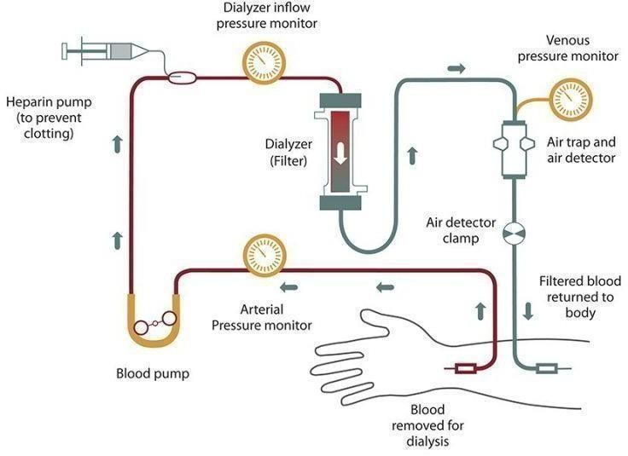

#### Figure 3.1: Traditional Monitoring Methods

Semi-automated systems offer a partial improvement over fully manual urine monitoring by increasing accuracy and reliability. However, the lack of active alert mechanisms, remote communication, and real-time response capabilities make them insufficient for critical care scenarios where immediate action is required—especially for conditions like oliguria. These limitations form the basis for proposing a low-cost, Arduino-based, fully automated alert system that can fill this gap effectively.

#### Absence of Real-Time Alerts

One of the most critical limitations of existing urine monitoring systems, especially in the care of dialysis patients, is the absence of real- time alert mechanisms. In most hospitals and care settings, urine output is either monitored manually or using semi-automated systems that record data but do not actively notify healthcare providers when urine production falls below safe thresholds. This lack of automated alerting is particularly dangerous in cases of oliguria, where timely detection and intervention

can prevent

complications such as fluid overload, electrolyte imbalance, or acute kidney injury. Without real-time alerts, caregivers may only become aware of reduced urine output during routine checks, which could be delayed by hours. This highlights a significant gap in patient safety and underscores the necessity of developing a system that can continuously monitor urine output and instantly trigger alarms—either through buzzers, visual indicators, or SMS alerts via GSM modules—to ensure timely clinical response and reduce the risk of complications.

## Lack of Home-Based Monitoring

Despite the importance of continuous urine output monitoring in managing patients with renal complications, especially those undergoing dialysis, most current systems are designed exclusively for hospital use, with little to no support for home-based monitoring. These hospital-grade systems often require specialized equipment, technical setup, and professional maintenance—making them inaccessible and impractical for patients receiving care at home. This is a significant concern, as a growing number of dialysis patients now opt for home-based or peritoneal dialysis, especially in rural or resource-limited areas where hospital visits are infrequent or costly. The lack of portable, easy-to-use, and affordable urine monitoring systems means that these patients are left without real-time insight into their fluid balance and kidney performance. In emergencies, such as a sudden drop in urine output (oliguria), early signs can go unnoticed, leading to delayed treatment, worsened conditions, or even hospitalization. In emergencies, such as a sudden drop in urine output, early signs can go unnoticed, leading to delayed treatment, worsened conditions, or even hospitalization. Furthermore, elderly patients or those with limited mobility may not have the ability to

monitor or interpret subtle changes in urine output. Therefore, the absence of home-based monitoring represents a critical gap in preventive care, emphasizing the need for a system that is lightweight, cost-effective, easy to use, and capable of providing real-time alerts to caregivers or healthcare professionals, even outside clinical environments.

## 3.5 Incompatibility with IoT and Remote Healthcare Models

Although monitoring urine output is essential for managing dialysis and kidney-related conditions, most existing systems are tailored for hospital environments, requiring specialized equipment and professional oversight. This makes them unsuitable for use at home, where a growing number of dialysis patients now receive treatment. These individuals, especially those in remote or underserved areas, are often unable to access continuous urine monitoring, increasing the risk of undetected complications like oliguria.

Without a simple, portable, and affordable monitoring solution, early warning signs may go unnoticed, potentially leading to serious health issues or emergency hospital visits. This gap is especially critical for elderly or immobile patients who may struggle with manual tracking. As a result, there is an urgent need for a user-friendly, real-time alert system that can be used independently at home, providing timely notifications to patients and caregivers to support proactive care and early intervention. Most existing devices are designed for hospital settings and involve bulky equipment, complex interfaces, and require trained medical personnel for operation and interpretation. As a result, these systems are not feasible for use in a home environment, where simplicity, portability, and cost-efficiency are crucial.

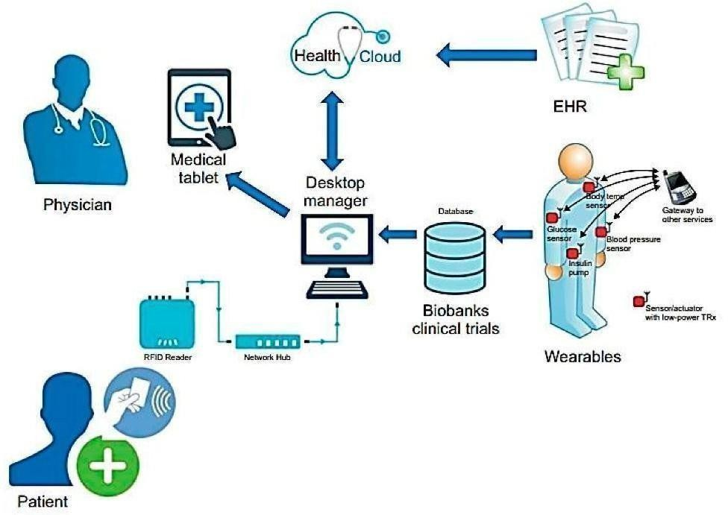

**Figure 3.2: Remote Healthcare Model**

## 3.6. Arduino in Biomedical Applications

Arduino has emerged as a powerful tool in the biomedical field due to its low cost, open-source nature, ease of programming, and flexibility in integrating various sensors and modules. It allows developers and researchers to create custom healthcare devices for monitoring vital signs, fluid levels, and patient safety in real-time. In biomedical applications, Arduino has been widely used to track parameters such as heart rate, body temperature, blood oxygen levels, and ECG signals by connecting with sensors like pulse monitors, thermistors, and SPO2 modules. It is also frequently used in the development of IV fluid monitoring systems, where it can automatically detect the flow rate, fluid level, and even send alerts to caregivers when intervention is needed. To address this, there is a clear need for a simple, user-friendly, and reliable monitoring system that can be used at home—preferably one that integrates real-time alerts via sound, visual indicators, or mobile communication modules like GSM or Wi-Fi.

# CHAPTER 4

### PROPOSED SYSTEM

The suggested system allows for real-time monitoring of dialysis patients with minimal urine production, also known as oliguric patients. It employs sensor technologies to collect crucial data such as heart rate and blood pressure, ensuring ongoing health monitoring. This information is delivered via Internet of Things (IoT) connectivity, allowing healthcare providers to receive real-time updates even from a distance. The system also contains GSM alarms, which warn patients and carers when any vital sign exceeds a predetermined threshold. This allows for faster intervention and lowers the risk of consequences. Overall, the figure 1 system improves patient safety and care, assisting healthcare providers in making faster decisions that result in better health outcomes.

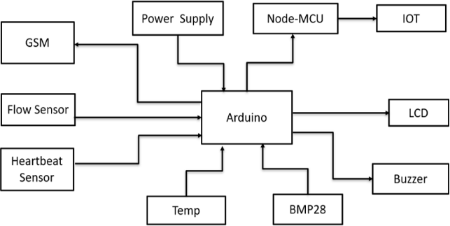

#### Figure 4.1: Proposed System Design

* 1. **GSM Modules Enable Connectivity:**

GSM modules are critical for Internet of Things (IoT) applications requiring remote connectivity. They enable devices to send and receive data over cellular networks. This enables users to monitor and manage equipment from anywhere. This functionality is especially beneficial in rural places without Wi-Fi, since it ensures immediate information transfer and management capabilities.

#### Power Supply is Essential for Functionality:

A stable power source is the foundation of any electronic system. In IoT applications, having are reliable and effective power source is crucial for devices to operate continuously. Various power supply alternatives, including as batteries, solar panels, & AC- DC converters, can be utilized dependent on the application needs, ensuring that devices remain functioning in diverse settings.

#### Node MCU Simplifies IoT Development:

The Node MCU platform, built around the ESP8266 Wi-Fi module, makes it easier to develop IoT applications. It offers a user- friendly programming environment and smoothly interfaces with a variety of sensors and modules. This ease of use shortens development cycles, allowing creators to swiftly prototype and launch ideas, which benefits startups and businesses eager to innovate.

#### Flow Sensors Monitor Liquid Dynamics:

Flow sensors are critical in applications that need monitoring of liquid flow rates. These sensors can monitor liquid velocity, providing useful information for industrial processes, irrigation systems, as well as smart home applications. Accurate flow measurement improves resource management and can result in significant cost savings.

#### Heartbeat Sensors Enhance Health Monitoring:

The integration of heartbeat sensors into IoT devices is transforming personal health monitoring. These sensors can monitor heart rates in real time, providing important data for telemedicine applications and personal health gadgets. Healthcare workers can make more informed judgements and improve patient outcomes by analyzing this data remotely.

#### Temperature and Pressure Readings:

The BMP28 sensor is well- known for its ability to precisely measure temperature and ambient pressure. In IoT applications, such sensors are critical for environmental monitoring, weather forecasting, & HVAC systems. BMP28's accurate data can be utilized to optimize energy use in buildings and improve temperature control systems, hence increasing energy efficiency.

#### Buzzers Facilitate User Alerts and Notifications:

The usage of buzzers in IoT devices improves user involvement by giving audible alerts & notifications. Buzzers are powerful communication tools, whether they are used to alert to a vital sensor reading or to remind people of a scheduled job. [10] This feature improves the responsiveness and usability of IoT systems by informing users of any significant changes in system status as soon as they occur.

#### Program Implementation:

The Arduino code employs JavaScript and various libraries. These include Software Serial and Wire for communication. Liquid Crystal_ PCF8574 controls the LCD panel. SFE_BMP180, SPI , Adafruit Sensor, and Adafruit_BMP280 all handle sensor data. The code sets up an LCD & a BMP280 sensor. These display critical health information to the user. The system measures temperature, heart rate, and breathing rate. It also monitors air pressure. The code checks if any value exceeds a safe limit. If a value is too high or too low, an SMS alert is delivered. Interrupts ensure precise counting of pulse and breathing measures.

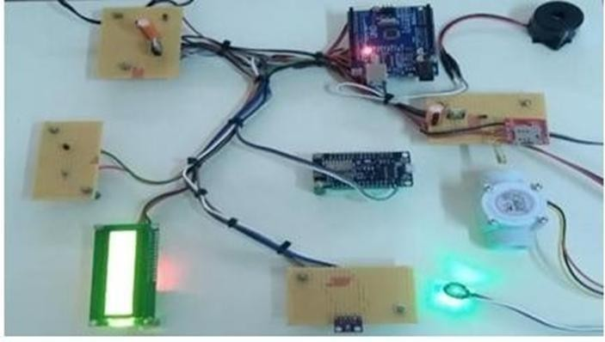

#### Figure 4.2: Multi-sensor Board Arduino

**TABLE 4.1: Comparison Between Existing Model AND Proposed Model**

|  |  |  |
| --- | --- | --- |
| **Aspect** | **Existing Method (Oliguria as a Predictive**  **Biomarker)** | **Proposed Method (Real-Time Risk Alert System Using Arduino)** |
| **Monitoring Technique** | Manually monitor urine output and clinical indicators. | Real-time monitoring is achieved by an automated sensor-based system. |
| **Technology Used** | None or a restricted number of clinical tools. | Arduino, flow sensors, heart rate monitors, temperature sensors,  BMP28s, and so forth. |
| **Real-Time Alerts** | There are no real- time notifications; instead, therapeutic intervention is Required following  detection. | Real-time warnings are delivered via buzzer, GSM, & IoT-based notifications. |
| **Data Logging** | Data logging is minimal or done  manually. | Automatic data logging with Node MCU and IoT systems. |
| **Accessibility** | Interpretation requires the expertise of educated medical  specialists. | The interface is user- friendly, with an LCD and IoT connection for  remote monitoring. |

proposed real-time risk alert system using Arduino. The proposed method offers automated, sensor-based real-time monitoring with enhanced technology, including Arduino, flow sensors, and IoT integration. It provides real-time alerts, automated data logging, user-friendly interfaces, portability, and cost-effectiveness.

#### Hardware requirements

* + 1. **Arduino UNO**

The Arduino Uno is a microcontroller board based on the ATmega328. It has 14 digital input/output pins (of which 6 can be used as PWM outputs), 6 analog inputs, a 16 MHz crystal oscillator, a USB connection, a power jack, an ICSP header, and a reset button. It contains everything needed to support the microcontroller; simply connect it to a computer with a USB cable or power it with an AC- to-DC adapter or battery to get started. The Uno differs from all preceding boards in that it does not use the FTDI USB-to-serial driver chip. Instead, it features the ATmega328 programmed as a USB-to- serial converter. "Uno" means one in Italian and is named to mark the upcoming release of Arduino 1.0.

The Uno and version1.0 will be the reference versions of Arduino, moving forward. The Uno is the latest in a series of USB Arduino boards, and the reference model for the Arduino platform; for a comparison with previous versions, The Arduino Uno is a microcontroller board based on the ATmega328. It has 14 digital input/output pins (of which 6 can be used as PWM outputs), 6 analog inputs, a 16 MHz crystal oscillator, a USB connection, a power jack, an ICSP header, and a reset button. It contains everything needed to support the microcontroller; simply connect it to a computer with a USB cable or power it with a AC-to-DC adapter or battery to get started. The Uno differs from all preceding boards in that it does not use the FTDI USB-to-serial driver chip. Instead, it features the ATmega8U2 programmed as a USB-to-serial converter.

"Uno" means one in Italian and is named to mark the upcoming release of Arduino 1.0. The Uno and version 1.0 will be the reference versions of Arduino, moving forward. The Uno is the latest in a series of USB Arduino boards, and the reference model for the Arduino platform for a comparison with previous versions.

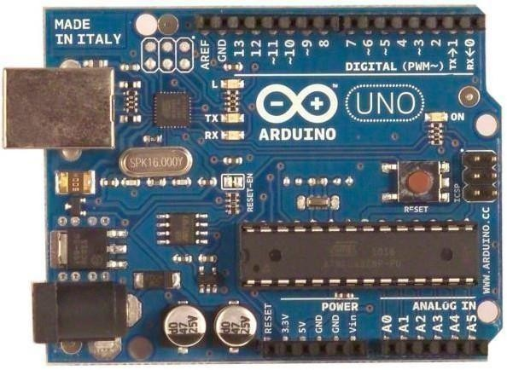

#### Figure 4.3: Arduino UNO

**Overview**

The Arduino Uno is a microcontroller board based on the ATmega328 (datasheet). It has 14 digital input/output pins (of which 6 can be used as PWM outputs), 6 analog inputs, a 16 MHz ceramic resonator, a USB connection, a power jack, an ICSP header, and a reset button. It contains everything needed to support the microcontroller; simply connect it to a computer with a USB cable or power it with a AC-to-DC adapter or battery to get started. The Uno differs from all preceding boards in that it does not use the FTDI USB-to-serial driver chip. Instead, it features the ATmega16U2 (ATmega8U2 up to version R2) programmed as a USB- to-serial converter. Revision 2 of the Uno board has a resistor pulling the 8U2 HWB line to ground, making it easier to put into DFU mode. Revision 3 of the board has the following new features: 1.0 pinout: added SDA and SCL pins.

AREF pin and two other new pins placed near to the RESET pin, the IOREF that allow the shields to adapt to the voltage provided from the board. In future, shields will be compatible both with the board that use the AVR, which

operate with 5V and with the Arduino Due that operate with 3.3V. The second one is a not connected pin, that is reserved for future purposes.

* Stronger RESET circuit.
* ATmega 16U2 replace the 8U2.

#### Table 4.2: Arduino UNO Specifications

|  |  |
| --- | --- |
| Microcontroller | ATmega328 |
| Operating Voltage | 5V |
| Input Voltage (recommended) | 7-12V |
| Input Voltage (limits) | 6-20V |
| Digital I/O Pins | 14 (of which 6 provide PWM  output) |
| Analog Input Pins | 6 |
| DC Current per I/O Pin | 40 mA |
| DC Current for 3.3V Pin | 50 mA |
| Flash Memory | 32 KB (ATmega328) of which 0.5  KB used by bootloader |
| SRAM | 2 KB (ATmega328) |
| EEPROM | 1 KB (ATmega328) |
| Clock Speed | 16 MHz |

* 1. **Schematic & reference design**

EAGLE files: arduino-uno-Rev3-reference-design.zip (NOTE: works with Eagle 6.0 and newer) Schematic: arduino-uno-Rev3-schematic.pdf Note: The Arduino reference design can use an ATmega8, 168, or 328, Current models use an ATmega328, but an ATmega8 is shown in the schematic for reference. The pin configuration is identical on all three processors.

## Power

The Arduino Uno can be powered via the USB connection or with an external power supply. The power source is selected automatically. External (non-USB) power can come either from an AC-to-DC adapter (wall-wart) or battery. The adapter can be connected by plugging a 2.1mm center-positive plug into the board's power jack. Leads from a battery can be inserted in the GND and Vin pin headers of the POWER connector.

The board can operate on an external supply of 6 to 20 volts. If supplied with less than 7V, however, the 5V pin may supply less than five volts and the board may be unstable. If using more than 12V, the voltage regulator may overheat and damage the board. The recommended range is 7 to 12 volts.

The power pins are as follows:

* + - * VIN-The input voltage to the Arduino board when it's using an external power source (as opposed to 5 volts from the USB connection or other regulated power source). You can supply voltage through this pin, or, if supplying voltage via the power jack, access it through this pin.
      * 5V-This pin outputs a regulated 5V from the regulator on the board. The board can be supplied with power either from the DC power jack (7 - 12V), the USB connector (5V), or the VIN pin of the board (7-12V). Supplying voltage via the 5V or 3.3V pins bypasses the regulator, and can damage your board. We don't advise it.
      * 3.3V- A 3.3volt supply generated by the on-board regulator. Maximum current draw is 50 mA.
      * GND-Ground pins.

## Memory

The ATmega328 has 32 KB (with 0.5 KB used for the bootloader). It also has 2 KB of SRAM and 1 KB of EEPROM (which can be read and written with the EEPROM library).

#### Input and Output

Each of the 14 digital pins on the Uno can be used as an input or output, using pinMode(), digitalWrite(), and digitalRead() functions. They operate at 5 volts. Each pin can provide or receive a maximum of 40 mA and has an internal pull-up resistor (disconnected by default) of 20-50 kOhms. In addition, some pins have specialized functions:

* + - * Serial: 0 (RX) and 1 (TX). Used to receive (RX) and transmit (TX) TTL serial data. These pins are connected to the corresponding pins of the ATmega8U2 USB-to-TTL Serial chip.
      * External Interrupts: 2 and 3. These pins can be configured to trigger an interrupt on a low value, a rising or falling edge, or a change in value. See the attachInterrupt()function for details.
      * PWM: 3, 5, 6, 9, 10, and 11. Provide 8-bit PWM output with the analogWrite() function.
      * SPI: 10 (SS), 11 (MOSI), 12 (MISO), 13 (SCK). These pins support SPI

communication using the SPI library.

* + - * LED: 13. There is a built-in LED connected to digital pin 13. When the pin is HIGH value, the LED is on, when the pin is LOW, it's off.
      * TWI: A4 or SDA pin and A5 or SCL pin. Support TWI communication using the Wire library. There are a couple of other pins on the board:
      * AREF: Reference voltage for the analog inputs. Used with analogReference().
      * Reset:Bring this line LOW to reset the microcontroller. Typically used to add a reset button to shields which block the one on the board.

#### Power supply

A power supply (sometimes known as a power supply unit or PSU) is a device or system that supplies electrical or other types of energy to an output load or group of loads. The term is most commonly applied to electrical energy supplies, less often to mechanical ones, and rarely to others**.**

#### Transformer

Transformer is a device used either for stepping-up or stepping- down the AC supply voltage with a corresponding decrease or increase in the current. Here, a transformer is used for stepping-down the voltage so as to get a voltage that can be regulated to get a constant 5V.

#### Rectifier

A rectifier is a device like semiconductor, capable of converting sinusoidal input waveform units into a unidirectional waveform, with a nonzero average component.

#### Filters

Capacitors are used as filters in the power supply unit. The action of the system depends upon the fact, that the capacitors stores energy during the conduction period and delivers this energy to the load during the inverse or non-conducting period. In this way, time during which the current passes through the load is prolonged and ripple is considerably reduced.

#### Voltage regulator

The LM78XX is three terminal regulators available with several fixed output voltages making them useful in a wide range of applications. IC7805 is a fixed voltage regulators used in this circuit.

Circuit diagram of such power supply is as shown in Figure 4.4

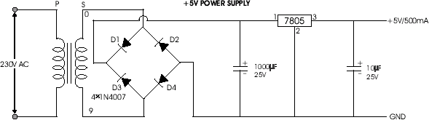

#### Figure 4.4: Five Volts Power Supply

* + 1. **Capacitor**

The capacitor is a component which has the ability or “capacity” to store energy in the form of an electrical charge producing a potential difference (Static Voltage) across its plates, much like a small rechargeable battery. There are many different kinds of capacitors available from very small capacitor beads used in resonance circuits to large power factor correction capacitors, but they all do the same thing, they store charge. In its basic form, a capacitor consists of two or more parallel conductive (metal) plates which are not connected or touching each other, but are electrically separated either by air or by some form of a good insulating material such as waxed paper, mica, ceramic, plastic or some form of a liquid gel as used in electrolytic capacitor.

The insulating layer between a capacitors plate is commonly called the Dielectric. There are two types of electrical charge, positive charge in the form of Protons and negative charge in the form of Electrons. When a DC voltage is placed across a capacitor, the positive (+ve) charge quickly accumulates on one plate while a corresponding and opposite negative (- ve) charge accumulates on the other plate. For every particle of +ve charge that arrives at one plate a charge of the same sign will depart from the -ve plate. Then the plates remain charge neutral and a potential difference due to this charge is established between the two plates. Once the capacitor reaches its steady state condition an electrical current is unable to flow through the capacitor itself and around the circuit due to the insulating properties of the dielectric used to separate the plates.

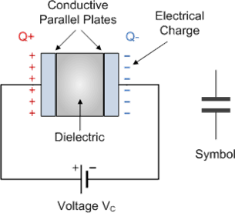

#### Figure 4.5: Capacitor

29

The parallel plate capacitor is the simplest form of capacitor. It can be constructed using two metal or metallised foil plates at a distance parallel to each other, with its capacitance value in Farads, being fixed by the surface area of the conductive plates and the distance of separation between them. Altering any two of these values alters the the value of its capacitance and this forms the basis of operation of the variable capacitors.

Also, because capacitors store the energy of the electrons in the form of an electrical charge on the plates the larger the plates and/or smaller their separation the greater will be the charge that the capacitor holds for any given voltage across its plates. In other words, larger plates, smaller distance, more capacitance.

By applying a voltage to a capacitor and measuring the charge on the plates, the ratio of the charge Q to the voltage V will give the capacitance value of the capacitor and is therefore given as: C = Q/V this equation can also be re-arranged to give the more familiar formula for the quantity of charge on the plates as: Q = C x V

Although we have said that the charge is stored on the plates of a capacitor, it is more correct to say that the energy within the charge is stored in an “electrostatic field” between the two plates. When an electric current flows into the capacitor, charging it up, the electrostatic field becomes more stronger as it stores more energy. Likewise, as the current flows out of the capacitor, discharging it, the potential difference between the two plates decreases and the electrostatic field decreases as the energy moves out of the plates. The property of a capacitor to store charge on its plates in the form of an electrostatic field is called the Capacitance of the capacitor. Not only

that, but capacitance is also the property of a capacitor which resists the change of voltage across it.

#### Voltage Rating of a Capacitor

All capacitors have a maximum voltage rating and when selecting a capacitor consideration must be given to the amount of voltage to be applied across the capacitor. The maximum amount of voltage that can be applied to the capacitor without damage to its dielectric material is generally given in the data sheets as: WV, (working voltage) or as WV DC, (DC working voltage). If the voltage applied across the capacitor becomes too great, the dielectric will break down (known as electrical breakdown) and arcing will occur between the capacitor plates resulting in a short-circuit. The working voltage of the capacitor depends on the type of dielectric material being used and its thickness.

The DC working voltage of a capacitor is just that, the maximum DC voltage and NOT the maximum AC voltage as a capacitor with a DC voltage rating of 100 volts DC cannot be safely subjected to an alternating voltage of 100 volts. Since an alternating voltage has an rms value of 100 volts but a peak value of over 141 volts. Then a capacitor which is required to operate at 100 volts AC should have a working voltage of at least 200 volts. In practice, a capacitor should be selected so that its working voltage either DC or AC should be at least 50 percent greater than the highest effective voltage to be applied to it.

Another factor which affects the operation of a capacitor is Dielectric Leakage. Dielectric leakage occurs in a capacitor as the result of an unwanted leakage current which flows through the dielectric material. Generally, it is assumed that the resistance of the dielectric is extremely high and a good insulator blocking the flow of DC current through the capacitor (as in a perfect capacitor) from one plate to the other. However, if the dielectric material becomes damaged due excessive voltage or over temperature, the leakage current through the dielectric will become extremely high resulting in a rapid loss of charge on the plates and an overheating of the capacitor eventually resulting in premature failure of the capacitor. Then never use a capacitor in a circuit with higher voltages than the capacitor is rated for otherwise it may become hot and explode.

#### NodeMCU

NodeMCU is an open source platform based on ESP8266 which can connect objects and let data transfer using the Wi-Fi protocol. NodeMCU is a low-cost open source IoT platform. It initially included firmware which runs on the ESP8266 Wi- Fi SOC from Express if Systems, and hardware which was based on the ESP-12 module. Later, support for the ESP32 32-bit MCU was added.

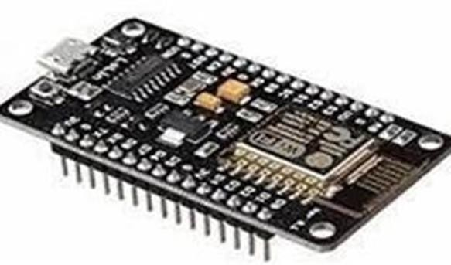

#### Figure 4.6: NodeMCU

The NodeMCU is an open-source firmware and development kit that is based on the ESP8266 Wi-Fi module. It combines the microcontroller unit (MCU) and Wi- Fi connectivity, making it a popular choice for IoT (Internet of Things) projects. NodeMCU is often used with the Arduino IDE, allowing developers to program it with Arduino-like code. It is versatile and capable of connecting to the internet, making it suitable for a wide range of IoT applications, including home automation, sensor networks, and more. Its ease of use and low cost have contributed to its popularity in the maker and IoT communities.

NodeMCU is particularly known for its compatibility with the Lua programming language, allowing developers to write scripts directly on the device. This makes it a versatile platform for rapid prototyping and development of IoT solutions. Additionally, NodeMCU provides GPIO pins for connecting various sensors and actuators, making it an excellent choice for creating interactive and connected projects

#### Liquid Crystal Display (LCD)

LCD is a type of display used in digital watches and many portable computers. LCD displays utilize to sheets of polarizing material with a liquid crystal solution between them. An electric current passed through the liquid causes the crystals to align so that light cannot pass through them. LCD technology has advanced very rapidly since its initial inception over a decade ago for use in lap top computers. Technical achievements have resulted in brighter displace, higher resolutions, reduce response times and cheaper manufacturing process.

The liquid crystals can be manipulated through an applied electric voltage so that light is allowed to pass or is blocked. By carefully controlling

where and what wavelength (color) of light is allowed to pass, the LCD monitor is able to display images. A backlight provides LCD monitor’s brightness. Over the years many improvements have been made to LCD to help enhance resolution, image, sharpness and response times. One of the latest such advancement is applied to glass during acts as switch allowing control of light at the pixel level, greatly improving LCD’s ability to display small-sized fonts and image clearly.

Other advances have allowed LCD’s to greatly reduce liquid crystal cell response times. Response time is basically the amount of time it takes for a pixel to “change colors”, in reality response time is the amount of time it takes a liquid crystal cell to go from being active to inactive.

#### BMP280 Sensor

The BMP280 is a high-precision, low-power digital sensor from Bosch Sensor designed to measure barometric pressure and temperature. It combines a piezo-resistive pressure sensing element and a temperature sensor on a single silicon die, together with 16-bit analog-to-digital converters for both channels.

The on-chip calibration data and signal processing deliver compensated pressure readings with resolutions down to 0.01 hPa (≈0.08 m) and temperature measurements accurate to ±1 °C. Its small footprint and capability to interface over either I²C or SPI make it ideal for wearable and portable applications where altitude estimation or environmental monitoring augments health data.

#### Key Features

* + - * Pressure range: 300 hPa to 1,100 hPa (simulates altitudes from 9,000 m below sea level up to 9,000 m above)
      * Temperature range: –40 °C to +85 °C
      * Pressure accuracy: ±1 hPa
      * Temperature accuracy: ±1 °C
      * Digital interface: I²C (up to 3.4 MHz) or SPI (up to 10 MHz)
      * Supply voltage: 1.71 V to 3.6 V (sensor core); typical module breakout accepts 3.3 V–5 V
      * Low current consumption: 2.7 µA (ultra-low-power mode) to 700 µA (maximum continuous operation)
        + Package: 2.0 × 2.5 × 0.93 mm LGA or 6-pin breakout module.

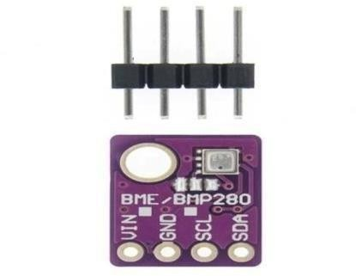

#### Figure 4.7: BMP280 Sensor

**Working Principle**

The BMP280’s pressure sensor consists of a thin diaphragmed membrane etched into the silicon. As ambient pressure deforms the membrane, the piezo-resistive elements change resistance proportionally. Simultaneously, a bandgap-based temperature sensor provides compensation for the pressure measurement. Internal calibration coefficients, stored in non- volatile memory, are applied in real time by the sensor’s digital signal processor, yielding highly accurate and drift-compensated pressure and temperature outputs.

# CHAPTER 5

**EXPERIMENTAL PROCEDURE**

* 1. **Continuous Monitoring**

The system includes modern sensors that monitor vital health factors to ensure patient safety and effective treatment. The heartbeat sensor continually monitors heart rate and provides real-time data to detect anomalies in heart rhythm. The BMP280 pressure sensor measures systolic and diastolic blood pressure to help alter dialysis treatment schedules. A flow sensor guarantees proper fluid passage and detects blockages that could jet paradise patient safety. Finally, a temperature sensor monitors body temperature to detect fevers or illnesses, allowing for early intervention. Together, these sensors provide a sophisticated monitoring system that enhances patient care during dialysis and other treatments.

#### Heartbeat Sensor

The heartbeat sensor, often based on photoplethysmography (PPG) or electrocardiogram (ECG) technology, continuously tracks the patient’s heart rate. It captures electrical activity or changes in blood volume and translates them into digital signals for real-time monitoring. Key functions include:

* + - * **Heart rate monitoring**: Detects beats per minute (BPM) to identify bradycardia (slow heart rate) or tachycardia (fast heart rate).
      * **Rhythm analysis**: Detects irregular heart rhythms such as arrhythmias.
      * **Data transmission**: Sends continuous data to a central monitoring unit for analysis and alerts.

Early detection of cardiac irregularities is critical during dialysis, where fluid shifts and blood pressure changes can stress the cardiovascular system.

#### BMP280 Pressure Sensor

The BMP280 is a high-precision sensor traditionally used for atmospheric pressure and temperature but can also be adapted for medical use to monitor blood pressure indirectly when calibrated with proper cuffs and algorithms.

* + - * **Blood pressure estimation**: Measures systolic and diastolic pressure using non-invasive techniques.
      * **Treatment adaptation**: Data helps clinicians adjust dialysis flow rates, ultrafiltration levels, or duration based on hemodynamic stability.
      * **Compact design**: Its small footprint makes it ideal for wearable or embedded medical devices.

Accurate blood pressure monitoring helps prevent hypotension or hypertension during dialysis sessions.

#### Flow Sensor

Flow sensors monitor the rate and consistency of fluid movement in dialysis machines and intravenous lines.

* + - * **Flow rate control**: Ensures that dialysate and blood flow remain within prescribed levels.
      * **Blockage detection**: Alerts for clots, kinks, or air bubbles that could obstruct flow.

#### Temperature Sensor

A high-precision digital temperature sensor (e.g., DS18B20 or equivalent) continuously monitors the patient's core body temperature.

* + - * **Fever detection**: Identifies early signs of infection, which is critical in immunocompromised or renal-compromised patients.
      * **Hypothermia prevention**: Detects drops in temperature that may occur due to fluid loss or machine malfunctions.
      * **Feedback loop**: Can trigger automatic alerts or adjustments in machine settings based on temperature thresholds.

Continuous temperature monitoring allows for prompt intervention before symptoms escalate, thus improving outcomes and comfort.

#### Data Processing:

The Arduino microcontroller is required for real- time data collecting from sensors. It continuously collects information, converts incoming signals into useful data, and ensures clarity and correctness. The final step entails analyzing the acquired data to draw conclusions or initiate actions based on certain criteria, allowing for fast responses to environmental changes. Overall, the Arduino's capacity to gather, interpret, and evaluate sensor data in real time makes it an effective tool for a variety of applications.

#### Alert Mechanism:

Local alarms sound an immediate buzzer when safety parameters exceed or fall below safe limits, requiring urgent action to protect humans. Additionally, the system offers remote warnings via a GSM module, which sends SMS messages to carers in order to provide prompt action. The Node MCU uploads real-time data to an IoT platform, allowing for continuous remote monitoring. This enables carers and healthcare providers to obtain current information, analyse trends, and make informed decisions. Together, local and distant alarms provide a comprehensive safety system. Figure 3 displays the SMS alert.

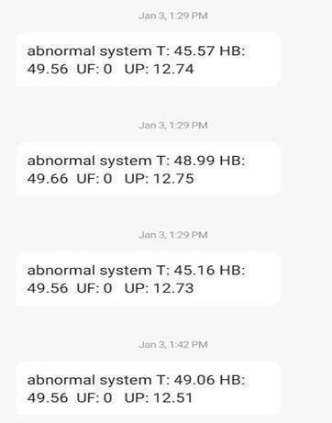

#### Figure 5.1: SMS ALERT

* 1. **Visualization:**

The LCD display provides carers with fast access to critical patient information, allowing them to quickly monitor vital signs and make informed decisions to improve patient care. The IoT dashboard allows healthcare personnel to view patient data remotely, ensuring that they are always informed about patient status. This integration of on-site and remote capabilities facilitate faster medical treatments and improves communication among care teams, resulting in a more efficient healthcare system. Figure 5.2. depicts the output.

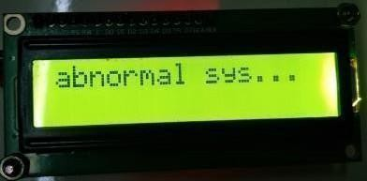

(a)

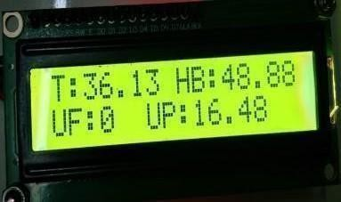

(b)

**Figure 5.2. (a) (b) LCD OUTPUT**

# CHAPTER 6

### RESULTS AND DISCUSSION

The system was rigorously tested under a variety of settings to determine how well it performed in real- world scenarios. First, the accuracy of sensor readings was assessed. The device tracked important health signs like heart rate, blood pressure, body temperature, and fluid flow. Each of these indicators was tracked with high precision. Any deviations from typical ranges were accurately recognized, resulting in quick alarms to ensure early intervention. Next, the system's ability to transmit notifications was tested. SMS notifications were delivered quickly using the GSM module. This ensured that carers received timely updates. Furthermore, an IoT dashboard gave real-time updates on the patient's condition.

This dashboard displays critical information clearly, allowing healthcare practitioners to make informed decisions swiftly. During testing, another focus was on ease of use. Carers described the LCD display and IoT dashboard as simple and user- friendly. They found the layout simple to navigate, allowing them to acquire critical information quickly and without stress. Overall, the testing validated the system's effectiveness in monitoring health metrics, generating timely notifications, and being user-friendly for carers. The combined qualities of these elements improve patient care and help healthcare workers with their regular tasks. Table 6.1 displays the anomalous results. architecture, confirming their effectiveness for the given task. These results provide confidence in the model's reliability and suggest it has successfully learned the relevant patterns from the training data while maintaining good generalization to unseen validation data.

### TABLE 6.1: NORMAL RESULTS

|  |  |  |  |  |
| --- | --- | --- | --- | --- |
| Timeline(UST) | Temp(celcius) | Heartbeat(BPM) | UF  (ml) | UP  (mm HG) |
| 2025-01-03T08:20:07+00:00 | 38.18 | 60.46 | 145.38 | 12.37 |
| 2025-01-03T08:20:24+00:00 | 38.25 | 65.66 | 148.96 | 12.36 |
| 2025-01-03T08:21:15+00:00 | 38.25 | 95.89 | 147.85 | 12.33 |
| 2025-01-03T08:21:32+00:00 | 38.25 | 65.95 | 145.35 | 12.4 |
| 2025-01-03T08:22:06+00:00 | 38.18 | 65.36 | 147.85 | 12.44 |
| 2025-01-03T08:22:40+00:00 | 38.18 | 69.46 | 148.53 | 12.32 |
| 2025-01-03T08:24:06+00:00 | 38.32 | 65.46 | 149.96 | 12.28 |
| 2025-01-03T08:24:23+00:00 | 38.32 | 69.66 | 149.85 | 12.3 |
| 2025-01-03T08:24:58+00:00 | 38.32 | 69.56 | 147.65 | 12.28 |
| 2025-01-03T08:26:05+00:00 | 38.25 | 69.56 | 150.25 | 12.26 |
| 2025-01-03T08:27:29+00:00 | 38.32 | 65.56 | 149.28 | 12.3 |

The recorded temperatures vary significantly, reaching a high of

38.93°C before lowering to 35.92°C, indicating a possible infection or other systemic disorders. Heartbeat rates range from 60 to 100 beats per minute, showing substantial Tachycardia at one point, which could have catastrophic consequences for the patient's cardiovascular health. Urinary flow (UF) is continuously at zero, while urinary pressure (UP) changes slightly but within a tight range, indicating steady renal function despite other anomalies. The data is timestamped down to the second, emphasizing the significance of precision monitoring in

recognizing and responding to patient health changes in real time. The combination of increased body temperature and reduced heart rate may suggest a dangerous underlying disease requiring quick medical intervention.

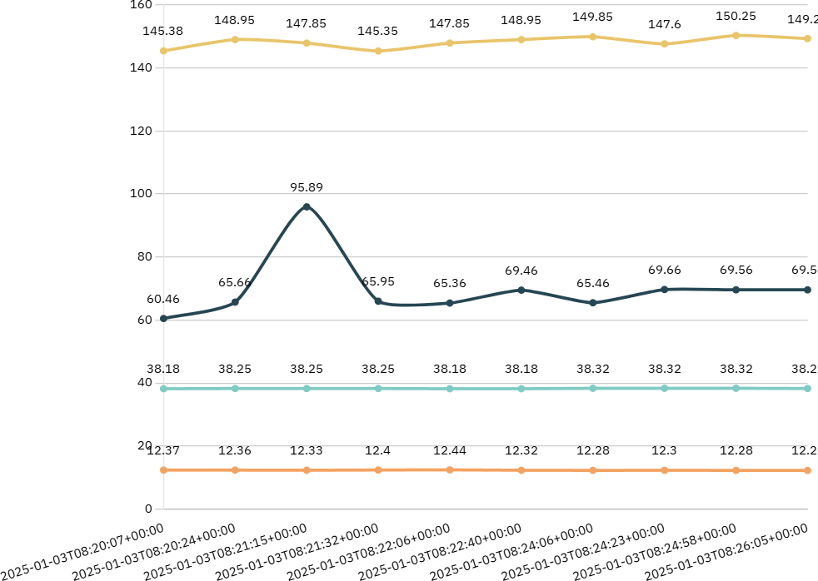

#### Figure 6.1: Chart Represents Normal Output

 Heartbeat(BPM)  Temperature (Celsius)  UP(mm Hg)

 UF(ml/s)

Figure 6.2 abnormal results show the importance of complete diagnostic assessments to determine the reasons of these physiological alterations. Continuous monitoring and assessment of vital signs is critical for successful

patient care management, particularly when abnormal physiological data are present.

### TABLE 6.2: NORMAL RESULTS

|  |  |  |  |  |
| --- | --- | --- | --- | --- |
| Timeline(UST) | Temp(celcius) | Heartbeat(BPM) | UF | UP |
| 2025-01-06T20:45:28+05:30 | 38.76 | 101.32 | 50.62 | 18.47 |
| 2025-01-06T20:45:46+05:30 | 38.82 | 100.54 | 53.25 | 18.48 |
| 2025-01-06T20:46:03+05:30 | 38.93 | 109.76 | 48.98 | 18.46 |
| 2025-01-06T20:46:20+05:30 | 35.92 | 105.05 | 45.63 | 18.47 |
| 2025-01-06T20:46:38+05:30 | 35.99 | 109.95 | 60.09 | 18.47 |
| 2025-01-06T20:46:55+05:30 | 35.99 | 108.97 | 55.45 | 18.48 |
| 2025-01-06T20:47:13+05:30 | 37.09 | 100.93 | 52.25 | 18.47 |
| 2025-01-06T20:47:31+05:30 | 37.57 | 105.93 | 48.95 | 18.47 |
| 2025-01-06T20:47:49+05:30 | 37.29 | 109.36 | 65.02 | 18.47 |
| 2025-01-06T20:48:06+05:30 | 36.95 | 106.95 | 46.99 | 18.46 |
| 2025-01-06T20:48:23+05:30 | 36.68 | 107.83 | 50.67 | 18.48 |

Table 6.2 temperature values remained consistent and within normal limits, varying slightly but remaining below 38.5°C. This demonstrates efficient bodily regulation, which is critical for health. Stability indicates that the individual is likely healthy and does not exhibit any indicators of infection or disease that would induce a fever.

The heart Rate reached the value Greater than 100 BPM, indicating a response to stress, activity, or emotions. This surge has important implications for understanding cardiovascular health and the autonomic nervous system. The heart rate's return to lower levels demonstrates the body's ability to recover from temporary stress, implying excellent overall health. Monitoring heart rate variability is critical for determining an individual's health and recovery potential. Urinary flow and output were steady throughout the monitoring period, indicating stable renal function. Normal urine production indicates healthy hydration and effective kidney performance, which is necessary for waste clearance and fluid balance in the body. This constancy is a good sign of general health.

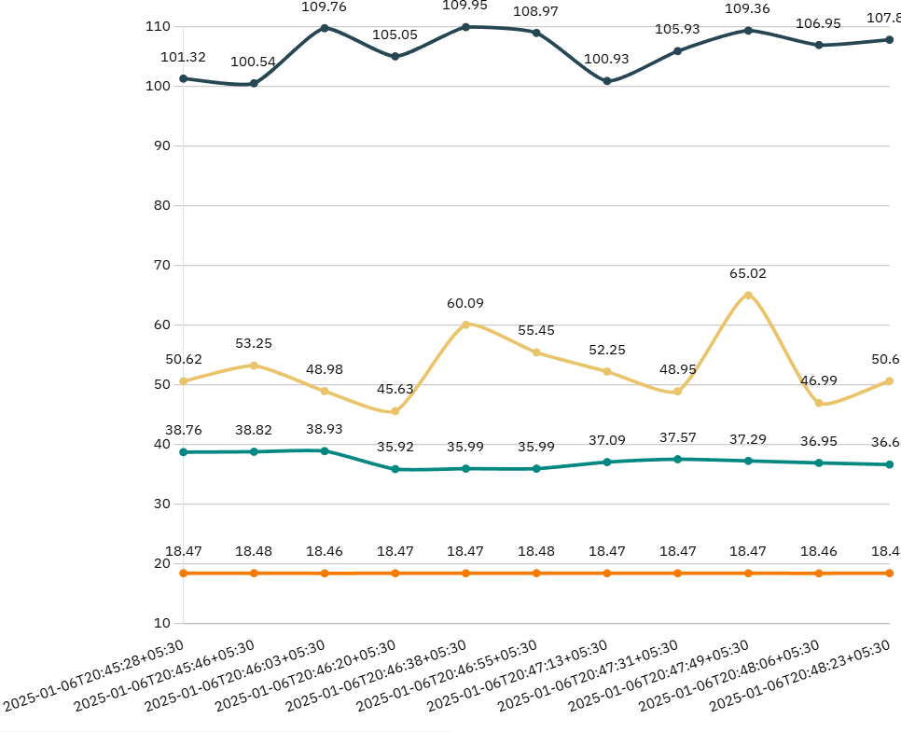

#### Figure 6.2: Chart represents abnormal output

 Heartbeat(BPM) Temperature (Celsius)

 UP(mm Hg)

 UF(ml/s)

Figure 6.1 shows how gathering data at 15-second intervals allows for more exact monitoring of physiological changes. This degree of detail is critical in acute treatment and for people who have continuing health difficulties. It helps to understand how bodies respond to various activities or times of rest. Accurate record keeping can show key trends in patient health. Table 6.1 gives a complete review of physiological indicators that can help clinicians improve patient care. The constant temperature, heart rate changes, and consistent urinary output indicate a healthy individual, while the thorough timing and monitoring provide information that can be used for both rapid medical assessments and long-term research projects. Understanding these measures is critical for identifying variations that may suggest health risks, making this data vital to healthcare providers.

# CHAPTER 7

### CONCLUSION AND FUTURE WORK

The management of dialysis patients requires constant vigilance, particularly in monitoring critical indicators such as urine output, which plays a vital role in assessing kidney function and fluid balance. Oliguria, or reduced urine output, is a key warning sign of deteriorating renal function and may precede severe complications such as fluid overload, electrolyte imbalance, and cardiovascular instability. Traditional monitoring techniques, which rely heavily on manual measurement and intermittent observation, are insufficient for ensuring timely detection and intervention. These methods not only increase the burden on healthcare staff but also expose patients to unnecessary risks due to delayed responses.

The proposed Real-Time Risk Alert System using Arduino addresses these limitations by offering a low-cost, automated, and continuous monitoring solution tailored for oliguric dialysis patients. Through the integration of sensors such as load cells or flow sensors, the system is capable of accurately tracking urine output in real time. The Arduino microcontroller processes this data and compares it against pre-defined thresholds, triggering immediate alerts via buzzers, SMS, or mobile notifications when urine output drops below critical levels.

One of the key strengths of this system is its adaptability and cost- effectiveness, making it especially beneficial in low-resource settings, rural clinics, and home-based dialysis care. It empowers caregivers and healthcare providers with real-time insights, allowing for prompt medical decisions and reducing dependence on manual monitoring. Furthermore, the use of IoT integration enhances its reach, enabling remote tracking and centralized data collection for long-term health management.

In essence, this project demonstrates how open-source microcontroller technology can be leveraged to develop a reliable, accessible, and scalable solution for high-risk medical monitoring. It not only improves patient outcomes through early detection and alert mechanisms but also contributes to the broader goal of advancing healthcare technology in an inclusive and sustainable manner.

# APPENDICES SOURCE CODE

#include <SoftwareSerial.h> #include <Arduino.h> #include <Wire.h>

#include <LiquidCrystal_PCF8574.h> #include <SFE_BMP180.h>

LiquidCrystal_PCF8574 lcd(0x27); // set the LCD address to 0x27 for a 16 chars and 2 line display

#include <SPI.h>

#include <Adafruit_Sensor.h> #include <Adafruit_BMP280.h> int show = -1;

int RXPin = 4; int TXPin = 3;

SoftwareSerial sSerial(RXPin, TXPin); #define BMP_SCL 13

#define BMP_SDO 12

#define BMP_SDA 11

#define BMP_CSB1 10

Adafruit_BMP280 bmp1(BMP_CSB1, BMP_SDA, BMP_SDO, BMP_SCL);

// 2 custom characters

byte dotOff[] = { 0b00000, 0b01110, 0b10001, 0b10001, 0b10001, 0b01110, 0b00000, 0b00000 };

byte dotOn[] = { 0b00000, 0b01110, 0b11111, 0b11111, 0b11111, 0b01110, 0b00000, 0b00000 };

// int pin1 = 7; float n1,n2;

int pin = 2;//HB

int pin_irq = 0; //IRQ that matches to pin 2 int be;

int p,lo=0;

volatile int IRQcount; int pin1 = 5;

void IRQcounter() { IRQcount++;

}

void setup()

{

if (!bmp1.begin()) {

// Serial.println("Sensor BMP280 device 1 was not found.");

//lcd.setCursor(0,1);

//lcd.print("not found"); while (1);

}

//Serial.println("Initialize BMP280 1 completed.");

//lcd.setCursor(0,1);

//lcd.print("found"); delay(2000);

int error;

pinMode(pin1, OUTPUT); digitalWrite(pin1, LOW); Serial.begin(9600); Serial.begin(9600); Serial.println("LCD...");

// wait on Serial to be available on Leonardo while (!Serial);

Serial.println("Probing for PCF8574 on address 0x27...");

// See <http://playground.arduino.cc/Main/I2cScanner> how to test for a I2C device.

Wire.begin();

Wire.beginTransmission(0x27); error = Wire.endTransmission(); Serial.print("Error: "); Serial.print(error);

if (error == 0) { Serial.println(": LCD found."); show = 0;

lcd.begin(20, 4); // initialize the lcd lcd.createChar(1, dotOff); lcd.createChar(2, dotOn);

} else {

Serial.println(": LCD not found.");

} // if lcd.setBacklight(255); lcd.home();

lcd.clear(); lcd.print("smart health "); lcd.setCursor(0, 1); lcd.print("care using iot"); delay(2000);

// lcd.clear();

// lcd.print(" using iot ");

// lcd.setCursor(0, 1);

// delay(2000);

attachInterrupt(pin_irq, IRQcounter, RISING);

}

void loop() // run over and over again

{

float pressure = bmp1.readPressure() / 100.0; pressure= pressure-981;

float g=analogRead(A1); g=70*(g/1023);

float p=analogRead(A0); p=100*(p/1023);

lo=lo+1;

}

lcd.clear(); lcd.setCursor(0, 0); lcd.print("T:"); lcd.print(g); lcd.print(" HB:"); lcd.print(p);

lcd.setCursor(0, 1); lcd.print("UF:"); lcd.print(be); lcd.print(" UP:"); lcd.print(pressure); delay(1000); Serial.print(g); Serial.print(',');

Serial.print(p);//pressure Serial.print(','); Serial.print(be); Serial.print(','); Serial.print(pressure);

Serial.print(','); Serial.println('\n');

delay(200); // Pause for 5 seconds. if(be>4000)

{

IRQcount=0; be=0;

}

be=IRQcount; delay(300);

if((g>45)||(p>100)||(pressure>20))

{

lcd.clear(); lcd.setCursor(0,0); lcd.print("abnormal sys... "); lcd.setCursor(0,1); digitalWrite(pin1,HIGH);

sSerial.println("AT"); //Sets the GSM Module in Text Mode delay(2000); // Delay of 1000 milli seconds or 1 second sSerial.println("AT+CMGF=1");

delay(2000);

sSerial.println("AT+CMGS=\"8248555869\"\r"); // Replace x with mobile number

delay(2000); sSerial.print("abnormal system "); sSerial.print("T: "); sSerial.print(g);

sSerial.print(" HB: "); sSerial.print(p); sSerial.print(" UF: "); sSerial.print(be); sSerial.print(" UP:"); sSerial.print(pressure); delay(1000);

sSerial.println((char)26);// ASCII code of CTRL+Z delay(500);

delay(1000);

}

else

{

digitalWrite(pin1,LOW); delay(1000);

}

}

# REFERENCES

1. Kumar, V.M.S., Selvaraj, R., Sasikanth, S., Kumar, E.K(2022). Quantification of Urinary Bladder for Early Detection of Hazard in Oliguric Patient Under Dialysis Using Embedded System. In: Das, K.N., Das, D., Ray, A.K., Suganthan, P.N. (eds) Proceedings of the International Conference on Computational Intelligence and Sustainable Technologies. Algorithms for Intelligent Systems. Springer,Singapore. doi.org/10.1007/978-981-16-6893-7_20
2. Dakurah, M.N., Koo, C., Choi, W., Joung, Y.-H.: Implantable bladder sensors: a methodological review. Int. Neurorol. J.19(3), 133–141 (2015)
3. Niestoruk, L., Beuth, T., Petry, K., Balzer, M., Stork, W.,Mueller-Glaser, K.: A concept for wearable long-term urinarybladder monitoring with ultrasound. Feasibility study. In: 5th European DSP Education and Research Conference(EDERC). Amsterdam, pp. 134–138 (2012)
4. Dakurah, M.N., Koo, C., Choi, W.S., &amp; Joung, Y. (2015).Implantable Bladder Sensors: A Methodological Review.International Neurourology Journal, 19, 133 - 141.
5. Shin, S., Moon, J., Kye, S., Lee, K., Lee, Y.S., Kang, H.: Continuous bladder volume monitoring system for wearable applications. In: 39th Annual International Conference of the IEEE Engineering in Medicine and Biology Society (EMBC), Seogwipo, pp. 4435–4438 (2017)
6. Zainol, Muhammad &amp; Farook, Rohani &amp; Hassan, Rosilah &amp; Hanah, Aznor &amp; Abdul Rejab, Mohamad Rizal &amp; Husin, Zulkifli. (2019). A New IoT Patient Monitoring System for Hemodialysis Treatment. 46-50.10.1109/ICOS47562.2019.8975703.
7. Hoste EA, Bagshaw SM, Bellomo R, et al. Epidemiology of acute kidney injury in critically ill patients: the multinational AKI-EPI study. Intensive Care Med. 2015;41(8):1411-1423.doi: 10.1007/s00134-015-3934-7
8. Gameiro J, Marques F, Lopes JA. Long-term consequences of acute kidney injury: a narrative review. Clin Kidney J. 2020;14(3):789-804.

doi: 10.1093/ckj/sfaa177

1. Lee CC, Kuo G, Chan MJ, et al. Characteristics of and outcomes after dialysis-treated acute kidney injury, 2009-2018: a Taiwanese multicenter study. Am J Kidney Dis.2023;81(6):665-674.e1.

doi: 10.1053/j.ajkd.2022.08.022

1. Selby NM. Electronic alerts for acute kidney injury. Curr OpinNephrol Hypertens. 2013;22(6):637-642.

doi:10.1097/MNH.0b013e328365ae84

### LIST OF PAPERS PUBLISHED

Dr.A.Sridevi, Keerthana D, Kirubashini P, Kiruthiga M, Lakshitha S M,

“Real-Time Risk Alert System for Oliguric Dialysis Patients Using Arduino". International Conference on Visual Analytics and Data Visualization (ICVADV-2025), Francis Xavier Engineering College, Tirunelveli, India. On 5th March,2025**.(Accepted for IEEE Explorer).**



|  |  |  |
| --- | --- | --- |
| 200 | Highly Accurate Vgg-19 Model Optimized Deep Learning Classifier for Breast Cancer Identification and Sub Types Classification  Subhikshaa Jayarani M, Kabilan R, Allwin Devaraj S | 1283 |
| 201 | Iot-driven Predictive Analytics for Precision Harvest Timing with Lightgbm Models  S. Lourdu Jame, Chitra Sabapathy Ranganathan, S. K. Saravanan, Bharat Tidke, E. Punarselvam, M. Rajmohan | 1288 |
| 202 | Real-time Risk Alert System for Oliguric Dialysis Patients using Ardiuno  Sridevi. A, Kirubashini. P, Lakshitha S. M. , Keerthana. D, Kiruthiga. M | 1294 |
| 203 | Revolutionizing Mouse Cursor Control for Enhanced User Interaction  L Sherin Beevi, Joe Prathap, P. M. , Harsha G, Jeeva N, Jeevashree R | 1301 |
| 204 | An Experimental Evaluation of Machine Learning Models for Basketball Performance Forecasting  Arpana Prasad, V. Asha, N Mithili Devi, Arpith P A, Ashish M Kumar, Aravindh J | 1307 |
| 205 | An Enhanced Approach to Detect the Eight Stages of Osteoarthritis using Learning Algorithm  Kumaragurubaran T, Madhumita P, Kavyashree B N, Senthil Pandi S | 1312 |
| 206 | Advanced Ai-powered Platform for Personalized Student Learning and Academic Enhancement  Gollapudi Mounika, Abhinav Gaddi, Pranav Gaddi, Kominneni Varun,  Kodumuri Vihar | 1318 |
| 207 | Advancing Hate Speech Detection: A Multilingual System using Llama- 2 for Real-time Analysis of Audio, Video, and Text Content  MD TALHA, J A M Rexie | 1325 |
| 208 | GPS and Iot-based Zone-specific Vehicle Speed Control System PRAKASH N B, VINSLET MERCY J, GOPIKA G, MERUTHULA M K, P. SAMUEL PAKIANATHAN, BINDHU A | 1332 |
| 209 | Personal Workout Trainer using Mediapipe and Opencv for Real- Time Guidance and Feedback  S. P. Priyanka, Sophia Janit | 1339 |
| 210 | Disaster Track: Ai-driven Real-time Monitoring and Instant Alerts for Emergency Response  Narmatha B. , Priyadharshini P. , Arthi S. , Malleswari M. , Yasaswini  M. , | 1348 |
| 211 | The Role of Features in Image Retrieval System: A Survey Gowmari M, Murugeswari G, Venkatalakshmi K | 1356 |
| 212 | Evaluation of Teacher Performance using Hybpso- Fa – A Hybrid Approach  Sanskriti Agarwal, Pitchika P N G Phani Kumar, Junali Jasmine Jena, Suchismita Das, Manas Ranjan Nayak, Mahendra Kumar Gourisaria | 1361 |
| 213 | Development of Vss-focv, and Ic Mppt Controllers for Pemfc Systems  Gurijala Sreedhar, CH Hussaian Basha, Shaik. Rafikiran, AVV Sudhakar, Faisal Alsaif, S. Senthilkumar | 1367 |
| 214 | Multimodal Rag for Enhanced Information Retrieval and Generation in Retail  Kailash Thiyagarajan | 1374 |
| 215 | Dissecting Segmentation Algorithms: A Performance Evaluation Framework based on Standardized Benchmarks  Bhavani M, Prithi Samuel | 1381 |
| 216 | Optimizing Crop Traits with ANN and Genetic Innovations for Sustainable Agriculture.  Dr Radha Mahendran, Ramanakar Reddy Danda, G. Omprakash, | 1387 |

Proceedings of the International Conference on Visual Analytics and Data Visualization (ICVADV-2025) DVD Part Number: CFP25VQ6-DVD; ISBN: 979-8-3315-2138-7

Real-Time Risk Alert System for Oliguric Dialysis Patients Using Ardiuno

Sridevi.A *Department of Electronics and Communication Engineering,*

*M.Kumarasamy College Of*

*Engineering, Karur, India.*

[sridevigunasekaranphd@gmail.com](mailto:sridevigunasekaranphd@gmail.com)

Kirubashini.P *Department of Electronics and Communication Engineering, M.Kumarasamy College Of*

*Engineering, Karur, India.*

[kirubashinitn@gmail.com](mailto:kirubashinitn@gmail.com)

Lakshitha S.M. *Department of Electronics and Communication Engineering,*

*M.Kumarasamy College Of*

*Engineering, Karur, India.* [*lakshithasm32@gmail.com*](mailto:lakshithasm32@gmail.com)

Keerthana.D *Department of Electronics and Communication Engineering,*

*M.Kumarasamy College Of*

*Engineering, Karur, India*

[keerthanadharma2004@gmail.com](mailto:keerthanadharma2004@gmail.com)

Kiruthiga.M *Department of Electronics and Communication Engineering,*

*M.Kumarasamy College Of*

*Engineering, Karur, India.*

[kiruthigamkce@gmail.com](mailto:kiruthigamkce@gmail.com)

***Abstract-* Oliguria is a serious condition characterized by low urine output, posing risks for dialysis patients. Quick detection and management are essential to prevent complications like fluid overload, electrolyte imbalances, and cardiovascular issues. This project presents a real- time risk alert system using an Arduino platform to monitor dialysis patients with oliguria. The system incorporates sensors to track vital signs such as heart rate, blood pressure, and dialysis fluid flow. It sends alerts via GSM technology to caregivers' mobile devices and allows real-time data monitoring through a web dashboard. An LCD display offers immediate visual feedback in the facility, while a buzzer provides alerts for critical changes. This system enhances patient safety and care by enabling prompt responses, aiming to reduce severe complications during dialysis.**

**Keywords: BMP28, Node MCU, GSM Modules, Heartbeat Sensors, Flow Sensors.**

1. Introduction

The Internet of Things (IoT) has transformed the way chronic diseases are tracked and managed in healthcare. IoT health monitoring solutions use wearable sensors to track vital signs in real time. This constant data collecting aids in the early detection of health disorders, which is critical for patients who require long-term care. The systems analyse data to detect aberrant readings and deliver notifications to patients and healthcare practitioners for immediate action. Personalised alarm levels can be adjusted depending on individual health needs, improving monitoring efficacy and enabling individualised treatments. This method promotes patient engagement & adherence to treatment programs, resulting in better health results. [1] focused on creating a reliable approach for detecting poor urine production (oliguria) in patients on dialysis. Researchers developed an

embedded device that continuously monitors urinary bladder volume and provides real-time data to alert healthcare providers to significant changes. This method outperformed traditional nursing evaluations by increasing the accuracy of oliguria identification. Early identification enabled prompt therapies, lowering the likelihood of sequelae from acute renal damage. [2] Research emphasises the importance of continuous monitoring in critically ill dialysis patients, as urine output is vital for measuring renal function. Integrating advanced monitoring technologies into care protocols allows healthcare providers to respond more effectively, improving patient outcomes. This study emphasises the significance of technological improvements in healthcare, especially in critical care situations. [3] The paper discusses various sensor technologies utilised for real-time monitoring of bladder conditions. These involve pressure sensors, volume sensors, along with wireless telemetry systems, which allow for continuous data collecting without invasive procedures. The authors emphasise that these sensors improve patient care and management by giving accurate assessments of bladder function. This enables healthcare providers to tailor therapies for conditions such as hyperactive bladders and urine retention. The methodological concerns for creating these sensors centre on biocompatibility, precision, and reliability, as well as the challenges of long-term use.

[4] Improved sensor designs increase functioning and patient comfort, and further clinical trials are recommended to test these technologies across different patient populations.

A new wearable gadget has been designed to continually monitor bladder volume, addressing the limitations of invasive procedures, which require specialised workers and may not provide timely information. This gadget uses ultrasonic technology for

Proceedings of the International Conference on Visual Analytics and Data Visualization (ICVADV-2025) DVD Part Number: CFP25VQ6-DVD; ISBN: 979-8-3315-2138-7

accurate measurement & has flexible transducers and compact circuitry, allowing for real-time data transfer in everyday contexts. [5]. The goal is to improve the care of patients with the lower urinary tract disorders by delivering critical information without requiring intrusive procedures. This technology can considerably help people with urine incontinence or neurogenic bladder dysfunction by providing timely bladder management notifications. [6] The study emphasises the potential for additional advancements in non- invasive bladder monitoring, which could improve patient care in urology. [7] The study looked at the variable rates of acute kidney injury (AKI) in intensive care units (ICUs), which sometimes suffer from biases such as insufficient definitions. The AKI-EPI study was a worldwide investigation that included 97 centres and focused on patients in their first week of ICU admission, utilising the KDIGO criteria to assess AKI. Among 1802 ICU patients, AKI was detected in 57.3%, showing a significant frequency. AKI patients had significantly lower kidney function at discharge, with nearly half having an estimated glomerular filtration rate of less than 60 mL/min/1.73 m². [8] The study found that AKI is associated with increased mortality & poorer outcomes, with consistent risks across geographies. It emphasises the importance of early detection and management of acute kidney injury in critical care settings.

1. Methodology

The suggested system allows for real-time monitoring of dialysis patients with minimal urine production, also known as oliguric patients. It employs sensor technologies to collect crucial data such as heart rate and blood pressure, ensuring ongoing health monitoring. This information is delivered via Internet of Things (IoT) connectivity, allowing healthcare providers to receive real-time updates even from a distance. The system also contains GSM alarms, which warn patients and carers when any vital sign exceeds a predetermined threshold. This allows for faster intervention and lowers the risk of consequences. Overall, the figure 1 system improves patient safety and care, assisting healthcare providers in making faster decisions that result in better health outcomes.

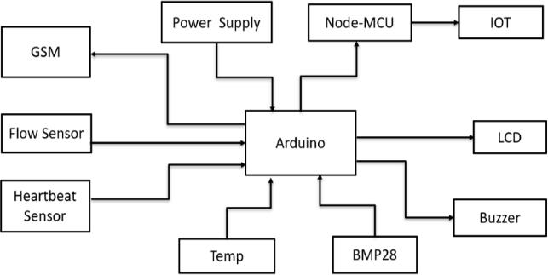

Fig. 1. System design

1. *GSM Modules Enable Connectivity:*

GSM modules are critical for Internet of Things (IoT) applications requiring remote connectivity. They enable devices to send and receive data over cellular networks. This enables users to monitor and manage equipment from anywhere. This functionality is especially beneficial in rural places without Wi-Fi, since it ensures immediate information transfer and management capabilities.

1. *Power Supply is Essential for Functionality:*

A stable power source is the foundation of any electronic system. In IoT applications, having a reliable and effective power source is crucial for devices to operate continuously. Various power supply alternatives, including as batteries, solar panels, & AC- DC converters, can be utilised dependent on the application needs, ensuring that devices remain functioning in diverse settings.[9].

1. *Node MCU Simplifies IoT Development:*

The Node MCU platform, built around the ESP8266 Wi-Fi module, makes it easier to develop IoT applications. It offers a user-friendly programming environment and smoothly interfaces with a variety of sensors and modules. This ease of use shortens development cycles, allowing creators to swiftly prototype and launch ideas, which benefits startups and businesses eager to innovate.

1. *Flow Sensors Monitor Liquid Dynamics:*

Flow sensors are critical in applications that need monitoring of liquid flow rates. These sensors can monitor liquid velocity, providing useful information for industrial processes, irrigation systems, as well as smart home applications. Accurate flow measurement improves resource management and can result in significant cost savings.

1. *Heartbeat Sensors Enhance Health Monitoring:*

The integration of heartbeat sensors into IoT devices is transforming personal health monitoring. These sensors can monitor heart rates in real time, providing important data for telemedicine applications and personal health gadgets. Healthcare workers can make more informed judgements and improve patient outcomes by analysing this data remotely.

1. *BMP28 Provides Accurate Temperature and Pressure Readings:*

The BMP28 sensor is well-known for its ability to precisely measure temperature and ambient pressure. In IoT applications, such sensors are critical for environmental monitoring, weather forecasting, & HVAC systems. BMP28's accurate data can be utilised to optimise energy use in buildings and improve temperature control systems, hence increasing energy efficiency.

Proceedings of the International Conference on Visual Analytics and Data Visualization (ICVADV-2025) DVD Part Number: CFP25VQ6-DVD; ISBN: 979-8-3315-2138-7

1. *Buzzers Facilitate User Alerts and Notifications:*

The usage of buzzers in IoT devices improves user involvement by giving audible alerts & notifications. Buzzers are powerful communication tools, whether they are used to alert to a vital sensor reading or to remind people of a scheduled job. [10] This feature improves the responsiveness and usability of IoT systems by informing users of any significant changes in system status as soon as they occur.

1. *Program Implementation*

The Arduino code employs JavaScript and various libraries. These include SoftwareSerial and Wire for communication. LiquidCrystal_PCF8574 controls the LCD panel. SFE_BMP180, SPI, Adafruit_Sensor, and Adafruit_BMP280 all handle sensor data. The code sets up an LCD & a BMP280 sensor. These display critical health information to the user. The system measures temperature, heart rate, and breathing rate. It also monitors air pressure. The code checks if any value exceeds a safe limit. If a value is too high or too low, an SMS alert is delivered. Interrupts ensure precise counting of pulse and breathing measures.

1. Experimental procedure
2. *Continuous Monitoring:*

The system includes modern sensors that monitor vital health factors to ensure patient safety and effective treatment. The heartbeat sensor continually monitors heart rate and provides real-time data to detect anomalies in heart rhythm. The BMP280 pressure sensor measures systolic and diastolic blood pressure to help alter dialysis treatment schedules. [11] A flow sensor guarantees proper fluid passage and detects blockages that could jeopardise patient safety. Finally, a temperature sensor monitors body temperature to detect fevers or illnesses, allowing for early intervention. Together, these sensors provide a sophisticated monitoring system that enhances patient care during dialysis and other treatments. Figure 2 depicts an Arduino board.

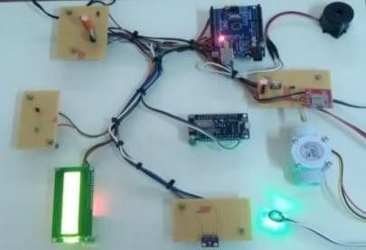

Fig. 2. Multisensor Board arduino

1. *Data Processing:*

The Arduino microcontroller is required for real- time data collecting from sensors. It continuously collects information, converts incoming signals into useful data, and ensures clarity and correctness. The

final step entails analysing the acquired data to draw conclusions or initiate actions based on certain criteria, allowing for fast responses to environmental changes. Overall, the Arduino's capacity to gather, interpret, and evaluate sensor data in real time makes it an effective tool for a variety of applications.

1. *Alert Mechanism:*

Local alarms sound an immediate buzzer when safety parameters exceed or fall below safe limits, requiring urgent action to protect humans. Additionally, the system offers remote warnings via a GSM module, which sends SMS messages to carers in order to provide prompt action. [12] The NodeMCU uploads real-time data to an IoT platform, allowing for continuous remote monitoring. This enables carers and healthcare providers to obtain current information, analyse trends, and make informed decisions. Together, local and distant alarms provide a comprehensive safety system. Figure 3 displays the SMS alert.

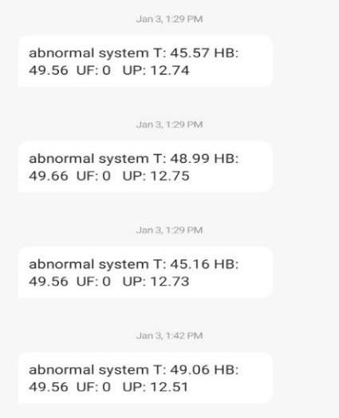

Fig. 3. SMS alert

1. *Visualization:*

The LCD display provides carers with fast access to critical patient information, allowing them to quickly monitor vital signs and make informed decisions to improve patient care. [13] The IoT dashboard allows healthcare personnel to view patient data remotely, ensuring that they are always informed about patient status. This integration of on-site and remote capabilities facilitates faster medical treatments and improves communication among care teams, resulting in a more efficient healthcare system. Figure 4 depicts the output.

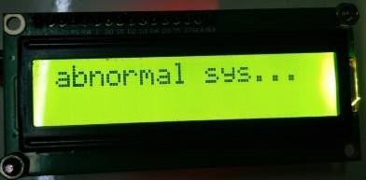

(a)

Proceedings of the International Conference on Visual Analytics and Data Visualization (ICVADV-2025) DVD Part Number: CFP25VQ6-DVD; ISBN: 979-8-3315-2138-7

|  |  |  |  |  |
| --- | --- | --- | --- | --- |
| 2025-01-06T20:48:41+05:30 | 36.61 | 48.48 | 0 | 18.5 |
| 2025-01-06T20:48:58+05:30 | 36.61 | 44.57 | 0 | 18.53 |
| 2025-01-06T20:49:16+05:30 | 36.54 | 74.58 | 0 | 18.52 |

Fig. 4. (a) (b) LCD output

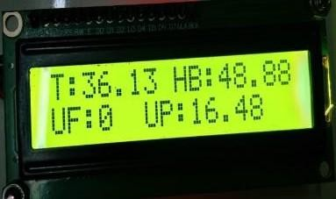(b)

The recorded temperatures vary significantly, reaching a high of 38.93°C before lowering to 35.92°C, indicating a possible infection or other systemic disorders. Heartbeat rates range from 44.57 to 74.58 beats per minute, showing substantial bradycardia at one point, which could have catastrophic consequences for the patient's cardiovascular health. Urinary flow

1. Result and discussion

The system was rigorously tested under a variety of settings to determine how well it performed in real- world scenarios. First, the accuracy of sensor readings was assessed. The device tracked important health signs like heart rate, blood pressure, body temperature, and fluid flow.[14]. Each of these indicators was tracked with high precision. Any deviations from typical ranges were accurately recognised, resulting in quick alarms to ensure early intervention. Next, the system's ability to transmit notifications was tested. SMS notifications were delivered quickly using the GSM module. This ensured that carers received timely updates. Furthermore, an IoT dashboard gave real-time updates on the patient's condition. This dashboard displays critical information clearly, allowing healthcare practitioners to make informed decisions swiftly. During testing, another focus was on ease of use. Carers described the LCD display and IoT dashboard as simple and user-friendly. They found the layout simple to navigate, allowing them to acquire critical information quickly and without stress. Overall, the testing validated the system's effectiveness in monitoring health metrics, generating timely notifications, and being user-friendly for carers.[15]. The combined qualities of these elements improve patient care and help healthcare workers with their regular tasks. Table 1 displays the anomalous results.

TABLE I. Abnormal Results

(UF) is continuously at zero, while urinary pressure (UP) changes slightly but within a tight range, indicating steady renal function despite other anomalies. [16]. The data is timestamped down to the second, emphasising the significance of precision monitoring in recognising and responding to patient health changes in real time. The combination of increased body temperature and reduced heart rate may suggest a dangerous underlying disease requiring quick medical intervention.[17].

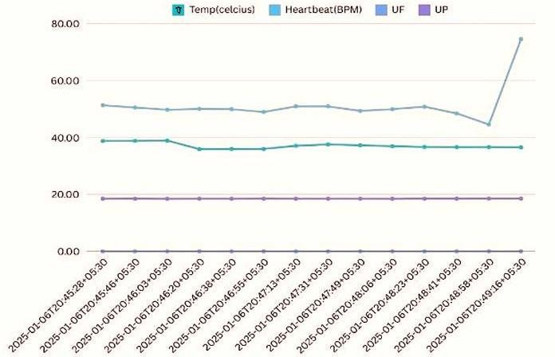

Fig. 5. Chatr represents abnormal output

Figure 5 abnormal results show the importance of complete diagnostic assessments to determine the reasons of these physiological alterations. [18] Continuous monitoring and assessment of vital signs is critical for successful patient care management, particularly when abnormal physiological data are present.

TABLE II. NORMAL RESULTS

|  |  |  |  |  |
| --- | --- | --- | --- | --- |
| **Timeline(UST)** | **Temp (celcius)** | **Heartbeat (BPM)** | **UF** | **UP** |
| 2025-01-06T20:45:28+05:30 | 38.76 | 51.32 | 0 | 18.47 |
| 2025-01-06T20:45:46+05:30 | 38.82 | 50.54 | 0 | 18.48 |
| 2025-01-06T20:46:03+05:30 | 38.93 | 49.76 | 0 | 18.46 |
| 2025-01-06T20:46:20+05:30 | 35.92 | 50.05 | 0 | 18.47 |
| 2025-01-06T20:46:38+05:30 | 35.99 | 49.95 | 0 | 18.47 |
| 2025-01-06T20:46:55+05:30 | 35.99 | 48.97 | 0 | 18.48 |
| 2025-01-06T20:47:13+05:30 | 37.09 | 50.93 | 0 | 18.47 |
| 2025-01-06T20:47:31+05:30 | 37.57 | 50.93 | 0 | 18.47 |
| 2025-01-06T20:47:49+05:30 | 37.29 | 49.36 | 0 | 18.47 |
| 2025-01-06T20:48:06+05:30 | 36.95 | 49.95 | 0 | 18.46 |
| 2025-01-06T20:48:23+05:30 | 36.68 | 50.83 | 0 | 18.48 |

|  |  |  |  |  |
| --- | --- | --- | --- | --- |
| **Timeline(UST)** | **Temp (celcius)** | **Heartbeat (BPM)** | **UF** | **UP** |
| 2025-01-03T08:20:07+00:00 | 38.18 | 49.46 | 538 | 12.37 |
| 2025-01-03T08:20:24+00:00 | 38.25 | 49.66 | 538 | 12.36 |
| 2025-01-03T08:21:15+00:00 | 38.25 | 95.89 | 538 | 12.33 |
| 2025-01-03T08:21:32+00:00 | 38.25 | 49.95 | 538 | 12.4 |
| 2025-01-03T08:22:06+00:00 | 38.18 | 49.36 | 538 | 12.44 |
| 2025-01-03T08:22:40+00:00 | 38.18 | 49.46 | 538 | 12.32 |
| 2025-01-03T08:24:06+00:00 | 38.32 | 49.46 | 538 | 12.28 |

Proceedings of the International Conference on Visual Analytics and Data Visualization (ICVADV-2025)

DVD Part Number: CFP25VQ6-DVD; ISBN: 979-8-3315-2138-7

consistent urinary output indicate a healthy individual, while the thorough timing and monitoring provide information that can be used for both rapid medical assessments and long-term research projects. [21] Understanding these measures is critical for identifying variations that may suggest health risks, making this data vital to healthcare providers.

|  |  |  |  |  |
| --- | --- | --- | --- | --- |
| 2025-01-03T08:24:23+00:00 | 38.32 | 49.66 | 538 | 12.3 |
| 2025-01-03T08:24:58+00:00 | 38.32 | 49.56 | 538 | 12.28 |
| 2025-01-03T08:26:05+00:00 | 38.25 | 49.56 | 538 | 12.26 |
| 2025-01-03T08:27:29+00:00 | 38.32 | 49.56 | 538 | 12.3 |
| 2025-01-03T08:27:46+00:00 | 38.39 | 49.46 | 538 | 12.24 |
| 2025-01-03T08:28:53+00:00 | 38.32 | 49.46 | 538 | 12.31 |
| 2025-01-03T08:30:00+00:00 | 38.32 | 49.56 | 538 | 12.24 |

Table 2 temperature values remained consistent and within normal limits, varying slightly but remaining below 38.5°C. This demonstrates efficient bodily regulation, which is critical for health. Stability indicates that the individual is likely healthy and does not exhibit any indicators of infection or disease that would induce a fever. The heart rate reached a peak of

95.89 BPM, indicating a response to stress, activity, or emotions. [19]. This surge has important implications for understanding cardiovascular health and the autonomic nervous system. The heart rate's return to lower levels demonstrates the body's ability to recover from temporary stress, implying excellent overall health. Monitoring heart rate variability is critical for determining an individual's health and recovery potential. Urinary flow and output were steady throughout the monitoring period, indicating stable renal function. Normal urine production indicates healthy hydration and effective kidney performance, which is necessary for waste clearance and fluid balance in the body. This constancy is a good sign of general health. [20].

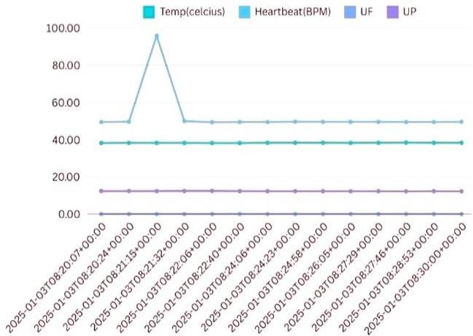

Fig. 6. Chart represents normal output

Figure 6 shows how gathering data at 15-second intervals allows for more exact monitoring of physiological changes. This degree of detail is critical in acute treatment and for people who have continuing health difficulties. It helps to understand how bodies respond to various activities or times of rest. Accurate recordkeeping can show key trends in patient health. Table 2 gives a complete review of physiological indicators that can help clinicians improve patient care. The constant temperature, heart rate changes, and

TABLE III. Comparison between existing model and proposed model

|  |  |  |
| --- | --- | --- |
| **Aspect** | **Existing Method (Oliguria as a**  **Predictive Biomarker)** | **Proposed Method (Real-Time Risk**  **Alert System Using Arduino)** |
| **Monitoring Technique** | Manually monitor urine output and clinical indicators. | Real-time monitoring is achieved by an  automated sensor- based system. |
| **Technology Used** | None or a restricted number of clinical tools. | Arduino, flow sensors, heart rate monitors, temperature sensors, BMP28s,  and so forth. |
| **Real-Time Alerts** | There are no real- time notifications; instead, therapeutic intervention is required following  detection. | Real-time warnings are  delivered via buzzer, GSM, & IoT-based notifications. |
| **Data Logging** | Data logging is minimal or done manually. | Automatic data  logging with  NodeMCU and IoT systems. |
| **Accessibility** | Interpretation requires the  expertise of educated medical specialists. | The interface is user-friendly, with an LCD and IoT connection for remote  monitoring. |
| **Power Supply** | Depends on hospital-grade power systems. | It runs on a modular power  supply for  portability. |
| **Integration with IoT** | Not compatible with IoT or remote monitoring technologies. | Fully integrated  with IoT for remote monitoring and analysis. |
| **Cost** | Critical care settings come at a high expense. | Affordable solution for widespread application,  including rural places. |
| **Predictive Accuracy** | Depends on clinical experience and interpretation. | Real-time data analytics is used to  spot issues early and accurately. |
| **Patient Safety** | Depends on timely human involvement. | Ensures safety through automated alarms and  continual monitoring. |

The table 3 compares the existing method of monitoring oliguria as a predictive biomarker with a

Proceedings of the International Conference on Visual Analytics and Data Visualization (ICVADV-2025) DVD Part Number: CFP25VQ6-DVD; ISBN: 979-8-3315-2138-7

proposed real-time risk alert system using Arduino. The proposed method offers automated, sensor-based real-time monitoring with enhanced technology, including Arduino, flow sensors, and IoT integration. It provides real-time alerts, automated data logging, user-friendly interfaces, portability, and cost- effectiveness. The proposed system ensures higher predictive accuracy and patient safety through continuous monitoring and automated alerts, making it suitable for widespread applications, including rural areas.

1. Conclusion

The Real-Time Risk Alert System for Oliguric Dialysis Patients with Arduino demonstrates the enormous impact of technology on healthcare. This technology enables continuous monitoring of patients' vital signs and other crucial parameters linked to their dialysis therapy. By delivering immediate alerts, it dramatically improves patient safety. Quick notifications can result in faster reactions from healthcare practitioners, which is critical for avoiding problems from delayed treatment. This system was designed to be both modular and scalable. This means that it can be modified and expanded when new requirements arise or technology develops. For example, new sensors or functionalities can be easily added, keeping the system current and effective over time. This versatility makes the Real-Time Risk Alert System an invaluable tool for controlling the health of dialysis patients. Integrating such technology allows healthcare practitioners to better protect patients' well- being and control treatment-related risks.

REFERENCES

1. Kumar, V.M.S., Selvaraj, R., Sasikanth, S., Kumar, E.K. (2022). Quantification of Urinary Bladder for Early Detection of Hazard in Oliguric Patient Under Dialysis Using Embedded System. In: Das, K.N., Das, D., Ray, A.K., Suganthan, P.N. (eds) Proceedings of the International Conference on Computational Intelligence and Sustainable Technologies. Algorithms for Intelligent Systems. Springer, Singapore. https://doi.org/10.1007/978-981-16-6893-7_20
2. Dakurah, M.N., Koo, C., Choi, W., Joung, Y.-H.: Implantable bladder sensors: a methodological review. Int. Neurorol. J. 19(3), 133–141 (2015)
3. Niestoruk, L., Beuth, T., Petry, K., Balzer, M., Stork, W., Mueller-Glaser, K.: A concept for wearable long-term urinary bladder monitoring with ultrasound. Feasibility study. In: 5th European DSP Education and Research Conference (EDERC). Amsterdam, pp. 134–138 (2012)
4. Dakurah, M.N., Koo, C., Choi, W.S., & Joung, Y. (2015). Implantable Bladder Sensors: A Methodological Review. International Neurourology Journal, 19, 133 - 141.
5. Shin, S., Moon, J., Kye, S., Lee, K., Lee, Y.S., Kang, H.: Continuous bladder volume monitoring system for wearable applications. In: 39th Annual International Conference of the IEEE Engineering in Medicine and Biology Society (EMBC), Seogwipo, pp. 4435–4438 (2017)
6. Zainol, Muhammad & Farook, Rohani & Hassan, Rosilah & Hanah, Aznor & Abdul Rejab, Mohamad Rizal & Husin, Zulkifli. (2019). A New IoT Patient Monitoring System for

Hemodialysis Treatment. 46-50. 10.1109/ICOS47562.2019.8975703.

1. Hoste EA, Bagshaw SM, Bellomo R, et al. Epidemiology of acute kidney injury in critically ill patients: the multinational AKI-EPI study. Intensive Care Med. 2015;41(8):1411-1423. doi: 10.1007/s00134-015-3934-7
2. Gameiro J, Marques F, Lopes JA. Long-term consequences of acute kidney injury: a narrative review. Clin Kidney J. 2020;14(3):789-804. doi: 10.1093/ckj/sfaa177
3. Lee CC, Kuo G, Chan MJ, et al. Characteristics of and outcomes after dialysis-treated acute kidney injury, 2009- 2018: a Taiwanese multicenter study. Am J Kidney Dis. 2023;81(6):665-674.e1. doi: 10.1053/j.ajkd.2022.08.022
4. Selby NM. Electronic alerts for acute kidney injury. Curr Opin Nephrol Hypertens. 2013;22(6):637-642. doi: 10.1097/MNH.0b013e328365ae84
5. Selby NM, Crowley L, Fluck RJ, et al. Use of electronic results reporting to diagnose and monitor AKI in hospitalized patients. Clin J Am Soc Nephrol. 2012;7(4):533-540. doi: 10.2215/CJN.08970911
6. Zarbock A, Nadim MK, Pickkers P, Gomez H, Bell S, Joannidis M, Kashani K, Koyner JL, Pannu N, Meersch M, Reis T, Rimmele T, Bagshaw SM, Bellomo R, Cantaluppi V, Deep A, De Rosa S, Perez-Fernandez X, Husain-Syed F, Kane-Gill SL, Kelly Y, Mehta RL, Murray PT, Ostermann M, Prowle J, Ricci Z, See EJ, Schneider A, Soranno DE, Tolwani A, Villa G, Ronco C, Forni LG (2023) Sepsis-associated acute kidney injury: consensus report of the 28th Acute Disease Quality Initiative Workgroup. Nat Rev Nephrol 19:401–417
7. Prowle, J.R., Bagshaw, S.M. & Forni, L.G. Tackling sepsis- associated AKI: are there any chances of REVIVAL with new approaches?. Intensive Care Med 50, 131–133 (2024). https://doi.org/10.1007/s00134-023-07294-3
8. Sun J, Qi Y, Wang W, Meng P, Han C, Chen B. Systemic Immune-Inflammation Index (SII) as a Predictor of Short- Term Mortality Risk in Sepsis-Associated Acute Kidney Injury: A Retrospective Cohort Study. Med Sci Monit. 2024 Jun 28;30:e943414. doi: 10.12659/MSM.943414. PMID: 38937949; PMCID: PMC11305056.
9. Zhang L, Liu L, Yan G, Ma X, Zhu G, Dong X, Lu Y, Zhang

H. Predictive Value of the Systemic Immune-Inflammation Index in the 28-Day Mortality for Patients with Sepsis- Associated Acute Kidney Injury and Construction of a Prediction Model. J Inflamm Res. 2024 Nov 12;17:8727-8739. doi: 10.2147/JIR.S488900. PMID: 39553309; PMCID: PMC11568861.

1. Bai H, Shen L, Jing L, Liu W, Sun Z, Tang N. [Study on the value of prothrombin time for predicting the severity and prognosis of septic patients]. Zhonghua Wei Zhong Bing Ji Jiu Yi Xue. 2022 Jul;34(7):682-688. Chinese. doi: 10.3760/cma.j.cn121430-20210614-00876. PMID: 36100403.
2. Özkarakaş H, Tekgül ZT, Arslan M, Bilgin MU, Eker HE, Okur O, Çalık B. Does Maintaining a Targeted Abdominal Perfusion Pressure Reduce Renal Damage in Patients with Septic Shock?: A Randomized, Controlled, and Open-label Study. Balkan Med J. 2023 Oct 20;40(6):415-421. doi: 10.4274/balkanmedj.galenos.2023.2023-5-9. Epub 2023 Sep

18. PMID: 37721127; PMCID: PMC10613750.

1. Gockel, H.P. & Ermert, A. & Callensee, W.. (1978). Ultrasonic measurement of residual urine. 25. 389-395.
2. Fechner, Pascal & Lockl, Jannik & Ruhland, Nicolas & Zuerl, Tristan & Zwede, Till. (2020). A Model for Predicting the Amount of Urine in the Bladder Based on App-generated Tracking Data. 2952-2954. 10.1109/BIBM49941.2020.9313381.
3. Kurihara, Y. & Yamasaki, Tomomasa & Kaburagi, Takashi & Matsumoto, T.. (2020). Model of Urine Accumulation in the Bladder and Method for Predicting Unconstrained Urine

Proceedings of the International Conference on Visual Analytics and Data Visualization (ICVADV-2025) DVD Part Number: CFP25VQ6-DVD; ISBN: 979-8-3315-2138-7

Volume Based on Absorption Spectrum of Urine. IEEE Access. PP. 1-1. 10.1109/ACCESS.2020.2986584.

1. Ali, Liaqat & Zhu, Ce & Zhang, Zhonghao & Liu, Yipeng. (2019). Automated Detection of Parkinson's Disease Based on Multiple Types of Sustained Phonations Using Linear

Discriminant Analysis and Genetically Optimized Neural Network. IEEE Journal of Translational Engineering in Health and Medicine. PP. 1-1. 10.1109/JTEHM.2019.2940900.

